**FPT ACADEMY INTERNATIONAL**



## FPT – APTECH COMPUTER EDUCATION

**SPACE-K ASTRONOMY**

|  |  |  |  |
| --- | --- | --- | --- |
| **Center Name** | | FPT – Aptech – HCM2  Address: 590 Cach Mang Thang Tam, District 3, Ho Chi Minh City | |
| **Instructor** |  | Ms. Le Mong Thuy |  |
| **Class** |  | T1.2302.E1 |  |
| **Group** |  | 6 |  |
| **Group members** | | **Name** | **Student ID** |
|  |  | Tran Quoc Viet | Student1455764 |
|  |  | Nguyen The Huy | Student1457504 |
|  |  | Luong Minh Thinh | Student1455767 |
| **Duration** |  | Start date: | 23th May 2023 |
|  | End date: | 23th June 2023 |

**This is to certify that**

**Mr.:**

**Tran Quoc Viet**

**Nguyen The Huy**

**Luong Minh Thinh**

**has successfully designed & developed**

**e-Project: Astronomy website**

**Submitted by:**

**Tran Quoc Viet**

**Date of issue:**

**23th May 2023**

**Authorized Signature**

Contents

FPT – APTECH COMPUTER EDUCATION 1

ACKNOWLEGMENT 3

SYNOSIS 3

PROBLEM DEFINITION 3

CUSTOMER'S REQUIREMENTS SPECIFICATIONS (CRS) 4

Client: Space-K Astronomy. 4

Project Objective: 4

Hardware/ Software Requirements: 5

SCOPE OF THE WORK (IN BRIEF) 6

ARCHITECTURE AND DESIGN OF THE SYSTEM 7

DIAGRAM OF THE WEBSITE 8

TASK SHEET REVIEW 1 9

SITE MAP 10

MOCK OF THE WEBSITE 11

1. Homepage. 11

2. News. 12

3. Planets. 13

4. Theory. 14

5. Constellation. 15

6. Comet. 16

7. Observation. 17

8. About us. 18

19

9. Sign in -Sign out 19

10. Logo. 20

TASK SHEET REVIEW 2 21

WEBSITE DESCRIPTION 22

1. Home page. 22

2. News. 23

2.1 List of News. 23

2.2 Detailed information. 24

3. Planet. 25

3.1 List of Planet. 25

3.2 Detailed information. 26

4. Theory. 27

4.1 List of Theory. 27

4.2 Detailed information. 28

5. Constellation. 29

5.1 List of Constellation. 29

5.2 Detailed information. 30

5.3 Explore the personalities of the zodiac signs. 31

6. Comet. 32

6.1 List of Comet. 32

6.2 Detailed information. 32

7. Observations. 33

7.1 List of Observations. 33

7.2 Detailed information. 33

8. About us. 34

9. Sign in/Sign up. 35

JAVASCRIPT DESCRIPTION 36

1. Catch-all event. 36

2. Product data Json and JavaScript. 38

3. Sign in 38

4. Sign up. 41

5. Index. 42

6. Page list. 43

7. Lucky Spin. 46

TASK SHEET REVIEW 3 48

# ACKNOWLEGMENT

As a member of the team, on behalf of the group, I would like to express our gratitude to all the team members for their dedicated efforts in completing the assignment on time. In particular, I would like to extend a heartfelt thank you to Ms. Le Mong Thuy, our teacher, and guide, who has been with us since the early days of learning HTML at FPT Aptech. With her wholehearted dedication and enthusiasm, she has guided us in the right direction and provided valuable feedback to ensure the success of our e-Project. She has helped us acquire new knowledge and reinforced the concepts we have learned, enabling us to apply them effectively in our e-Project.

# SYNOSIS

We have been assigned to design and develop a website that consolidates information about astronomy based on the client's requirements. The website will be named "Space-K Astronomy" and will focus on storing and updating the latest scientific data about the solar system, as well as theories about the universe. Additionally, it will also share scientific data about the cosmos observed through telescopes or gathered by satellites launched into space**.**

# PROBLEM DEFINITION

The information data consolidation is challenging due to several reasons. Firstly, there are limitations in our knowledge and understanding of astronomy. There is still much to learn and explore in this field, given the vastness of the subject and the vast amount of knowledge accumulated by humanity in the field of astronomy.

Additionally, we have encountered various issues in teamwork. It has been difficult to coordinate continuous collaboration among team members due to their busy schedules with work commitments and academic responsibilities.

The website is designed using HTML5 and JavaScript, specifically tailored for the Windows platform. It is expected to function smoothly on popular web browsers such as Chrome, Firefox, Internet Explorer, and Microsoft Edge, etc.

# CUSTOMER'S REQUIREMENTS SPECIFICATIONS (CRS)

## Client: Space-K Astronomy.

## Project Objective:

SpaceK is a type of electronic information portal that facilitates easy to access for everyone. With the development of the Internet, information about astronomy is now readily available from various sources and easily accessible from anywhere. However, due to the vast amount of information available, it can be time-consuming for individuals to find the specific information they need. Therefore, the client requests the team to develop a website that supports quick and accurate access to astronomy-related information. The website should also provide regular updates on astronomy and the latest technological advancements in the field.

The website is to be developed for the Windows Platform using HTML5, JavaScript and Geolocation. The site should work well in all leading browsers including Chrome, IE, ME, Firefox etc.

**Input to the system:**

The website allows users to search for information about planets in the solar system, such as Earth, Mars, and other planets. Users can also leave their comments on the articles.

**Output from the system:**

* A menu will categorize all the functions of the website.
* Display a list of information categorized by topic.
* Perform information search.
* Provide support in answering questions and addressing inquiries from readers and users.
* The website is capable of providing concise academic information about astronomy.
* Provide the latest updates on discoveries in the field of space science.

**Progress:**

* Provide easily understandable and engaging information about astronomy for students, kid.
* Support individuals with a passion for astronomy without requiring in-depth academic knowledge.
* Designed to help users access and explore the universe in an interesting and educational way.
* Create a learning and discovery environment in the field of astronomy without heavy academic requirements.
* Target individuals who want to expand their knowledge of the universe and have a passion for astronomy..

**Expected delivery date:** 23th-June-2023.

**List of deliverables:**

* Document Word.
* Source code.

## Hardware/ Software Requirements:

* **For developer:**

**Hardware:**

* + Intel Pentium 4 processor or higher
  + 1 Gigabytes of RAM or higher

**Software:**

* + Windows 7 OS or higher
  + Adobe Dreamweaver
  + Web browsers such as IE, Chrome or Firefox are supporting HTML5, CSS3, AngularJS, jQuery and JavaScript.
* **For web users:**

**Hardware:**

* + Intel Pentium 4 processor or higher
  + 512 Megabytes of RAM or higher

**Software:**

* + Windows XP OS or higher
  + Web browsers such as IE, Chrome or Firefox are supporting HTML5, CSS3 and JavaScr

# SCOPE OF THE WORK (IN BRIEF)

After a long and detailed discussion, our group has decided to create a website contain the following webpages:

1. **Homepage** (logo**)**: Homepage displays notable information.
2. **News**: Provide and update the latest news on human discoveries in space science, as well as the latest findings about the universe.
3. **Planets**: Display the solar system and information of those Planets
4. **Theory**: Display few theory the evolution of Space and Earth (persuasive the right of theory).
5. **Constellation**: "Display information about some famous constellations (name, location, picture, information)."
6. **Comet**: Display list of comets that fly close to the solar system and can be observed by humans (Halley's Comet / Comet Hale-Bopp / Comet Hyakutake)
7. **Observation**: Display list of famous Hubble
8. **About us**: Display Business Info
9. **Sign in**: Log in to leave a comment below the article.

# ARCHITECTURE AND DESIGN OF THE SYSTEM

Requested Page

**CLIENT**

**WEB BROWSER**

**SERVER**

**WEB SERVER**

**RENDERING**

**ENGINE**

**JavaScripts**

**jQuery**

**CSS CODE**

**AngularJS**



**HTML CODE**



Webpage request

# DIAGRAM OF THE WEBSITE

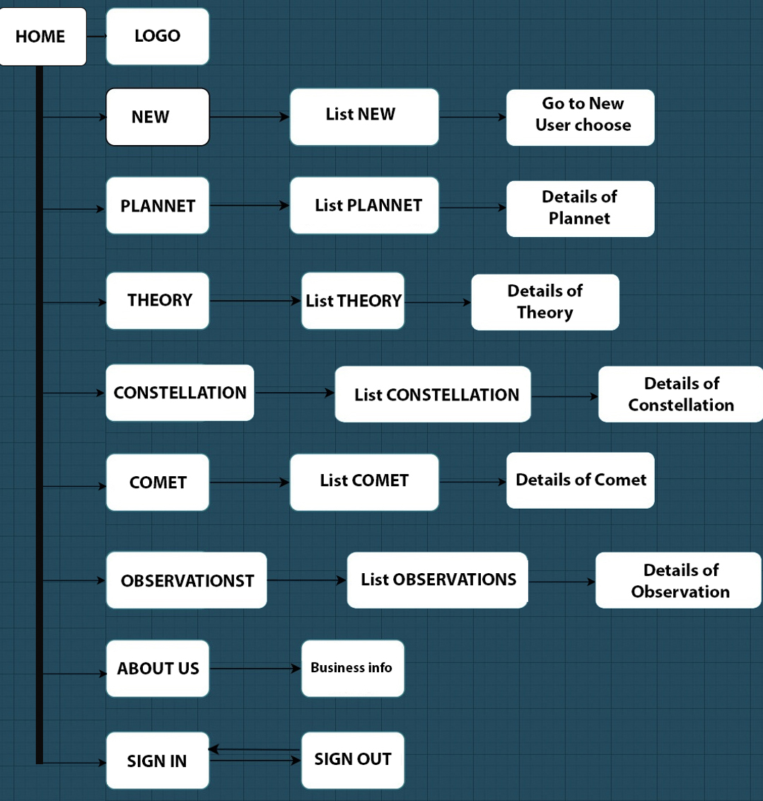



# TASK SHEET REVIEW 1

|  |  |  |  |  |  |  |  |
| --- | --- | --- | --- | --- | --- | --- | --- |
| **Project Ref. No.:**  **e-P/Advertisement Portal Management**  **System/01** | | **Project Title:** | **Activity Plan Prepared By:** | **Date of Preparation of Activity Plan:** | | | |
| **Sr.**  **No.** | **Task** | **Actual Start Date** | **Actual Days** | **Team Mate Names** | **Status** |
| 1 | Problem Statement | Astronomy  SpaceK | Viet  Huy Thinh | 23th-May-23 | 1 | Luong Minh Thinh | Completed |
| 2 | Analysis of Astronomy SpaceK requirements about the website | 23th-May-23 | 1 | Tran Quoc Viet | Completed |
| 3 | The scope of the work (in brief) | 23th-May-23 | 1 | Tran Quoc Viet | Completed |
| 4 | Architecture and design of the system | 23th-May-23 | 1 | Nguyen The Huy | Completed |
| 5 | Diagram of the website | 23th-May-23 | 1 | Nguyen The Huy | Completed |
| 6 | Task Sheet | 23th-May-23 | 1 | Luong Minh Thinh | Completed |

|  |  |
| --- | --- |
| **Date: 27th May 2023** | |
| Signature of Instructor:  **Ms. Le Mong Thuy** | Signature of Team Leader:  **Tran Quoc Viet** |

# SITE MAP

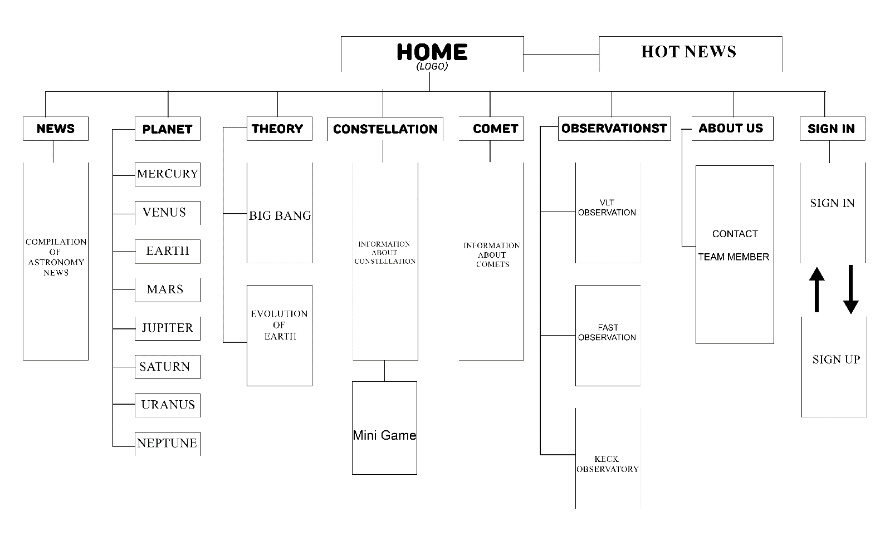

# MOCK OF THE WEBSITE

1. **Homepage.**

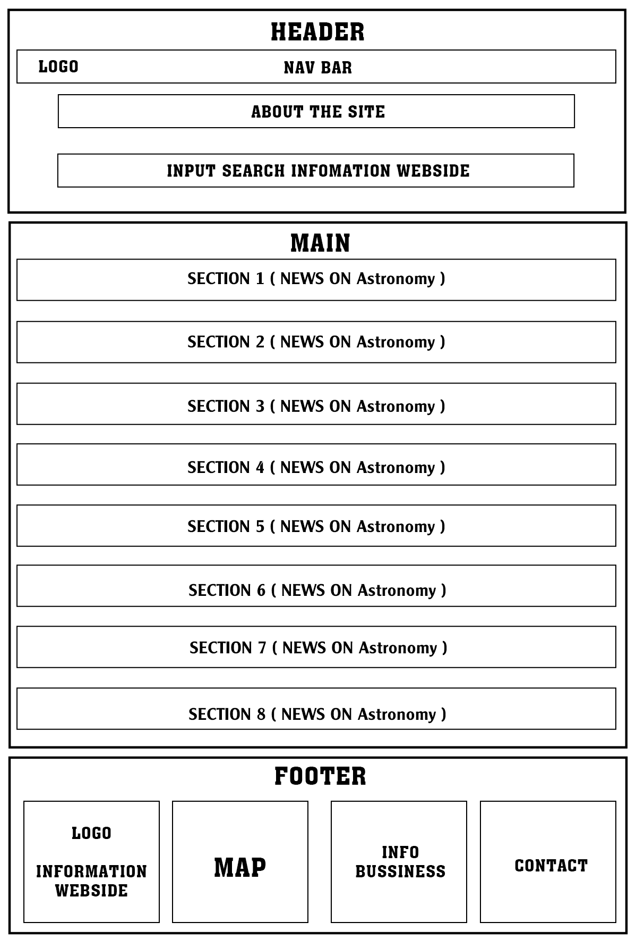

1. **News.**

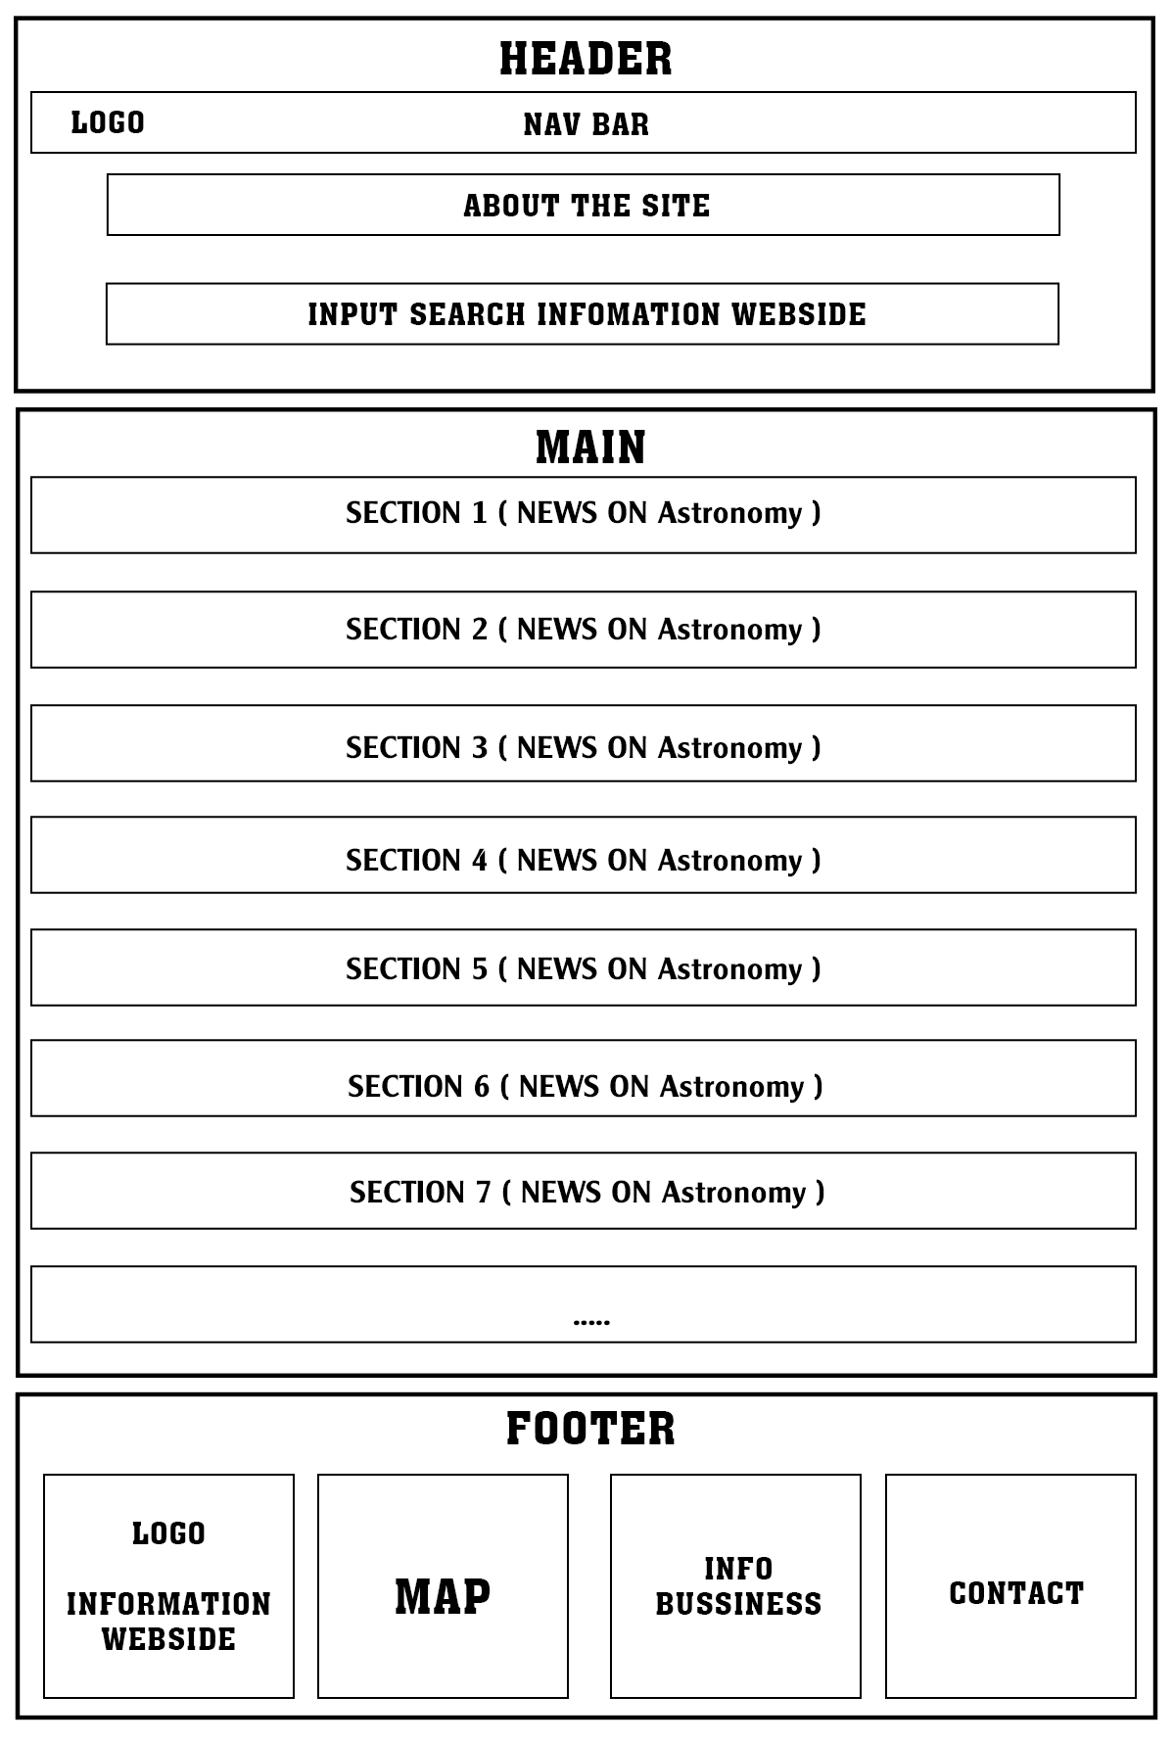

1. **Planets.**

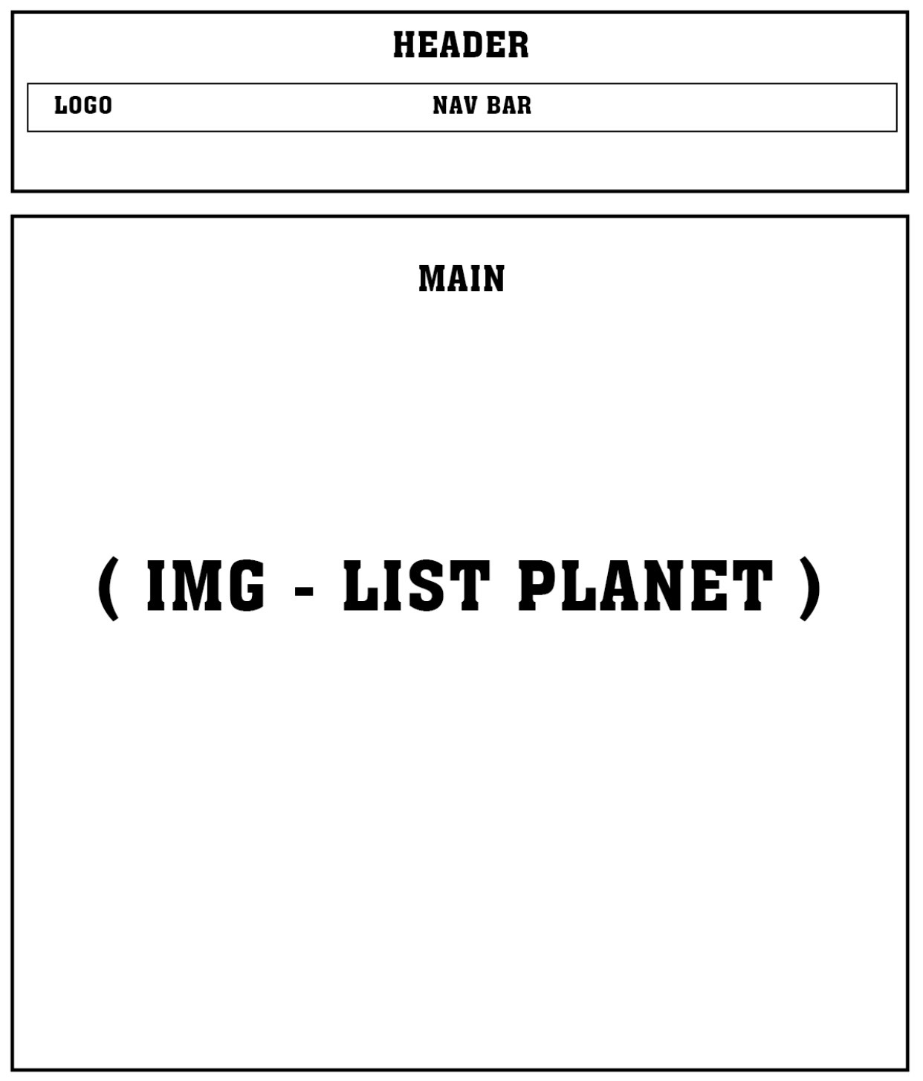

1. **Theory.**

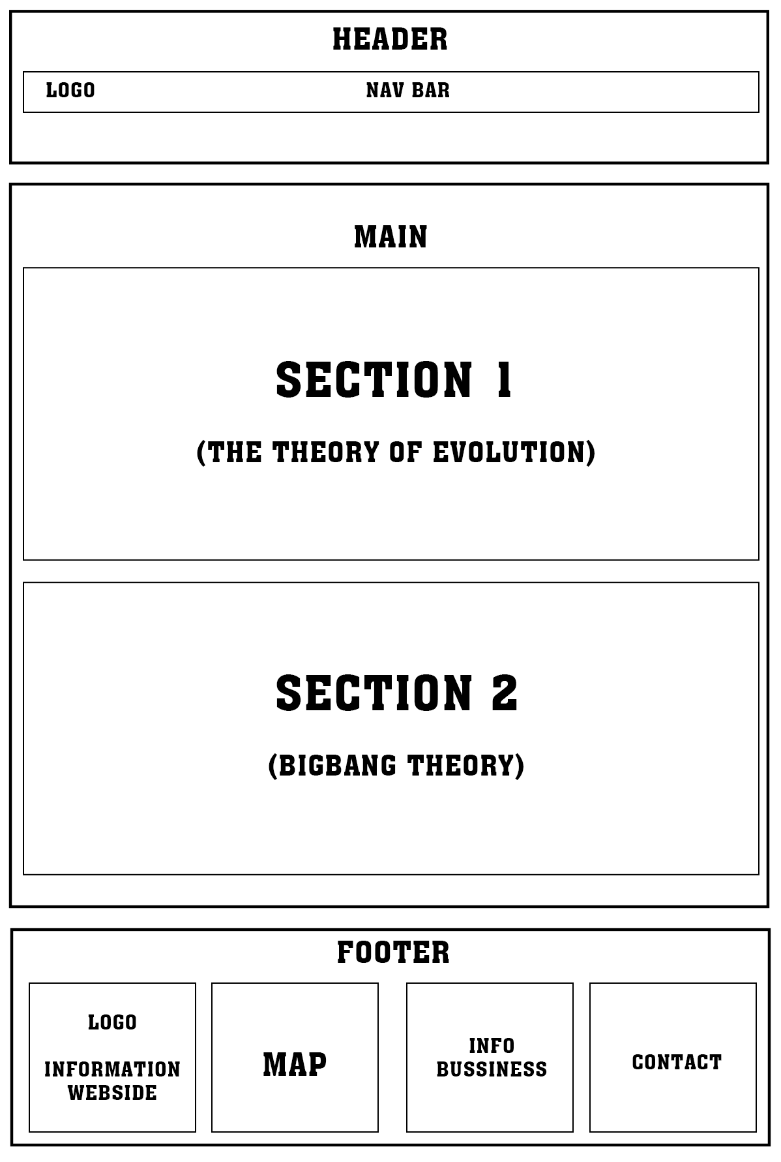

1. **Constellation.**

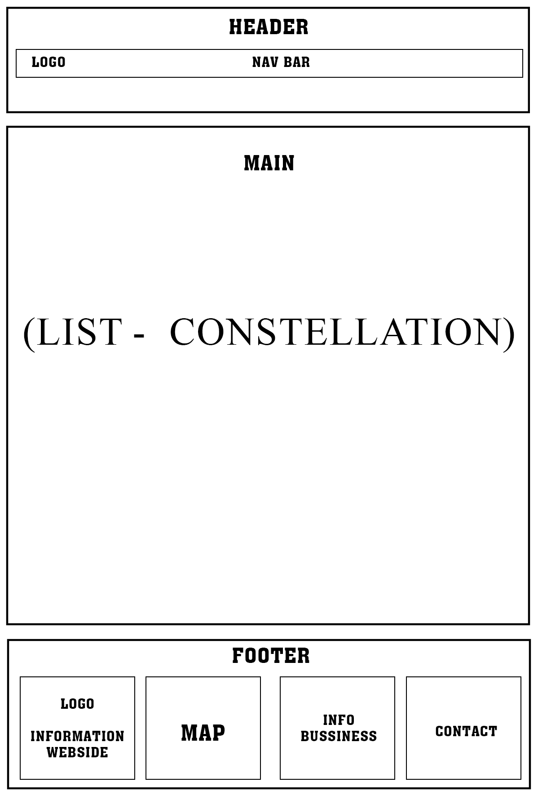

1. **Comet.**

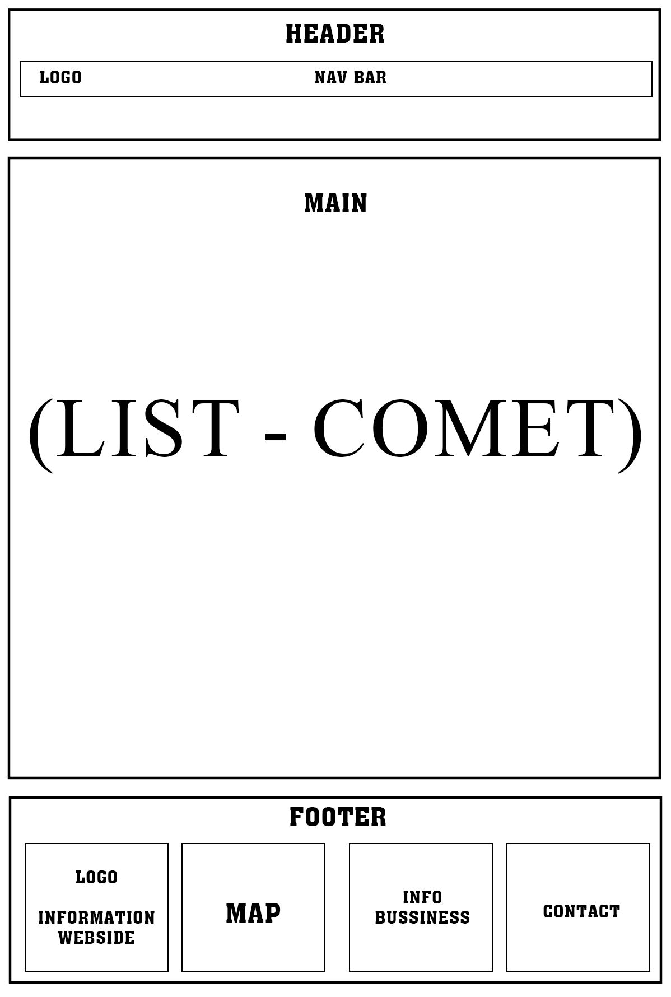

1. **Observation.**

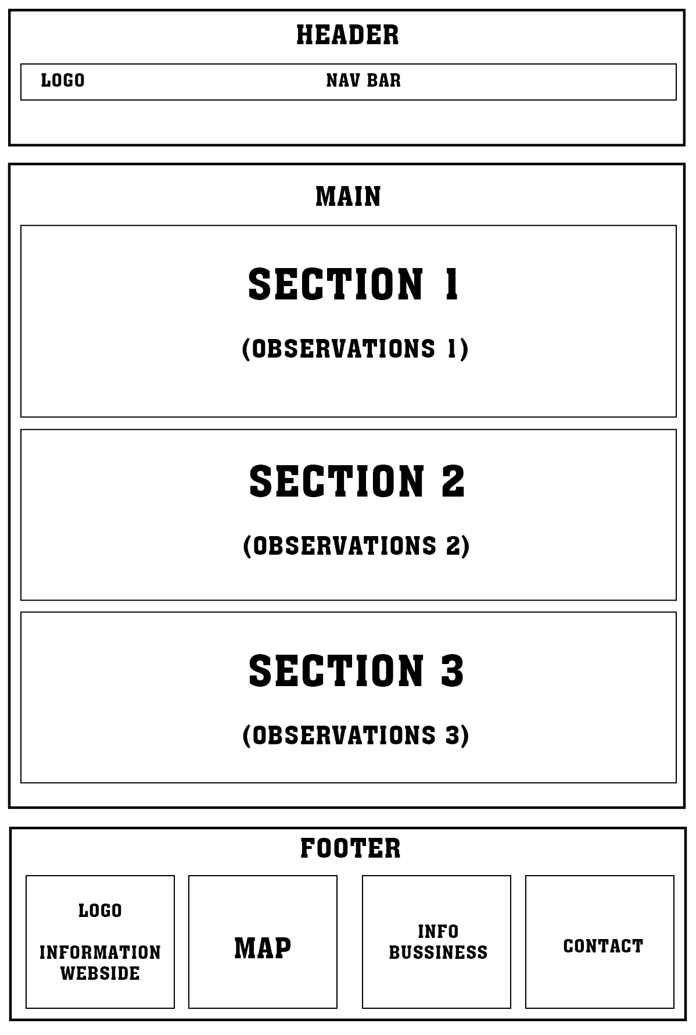

1. **About us.**

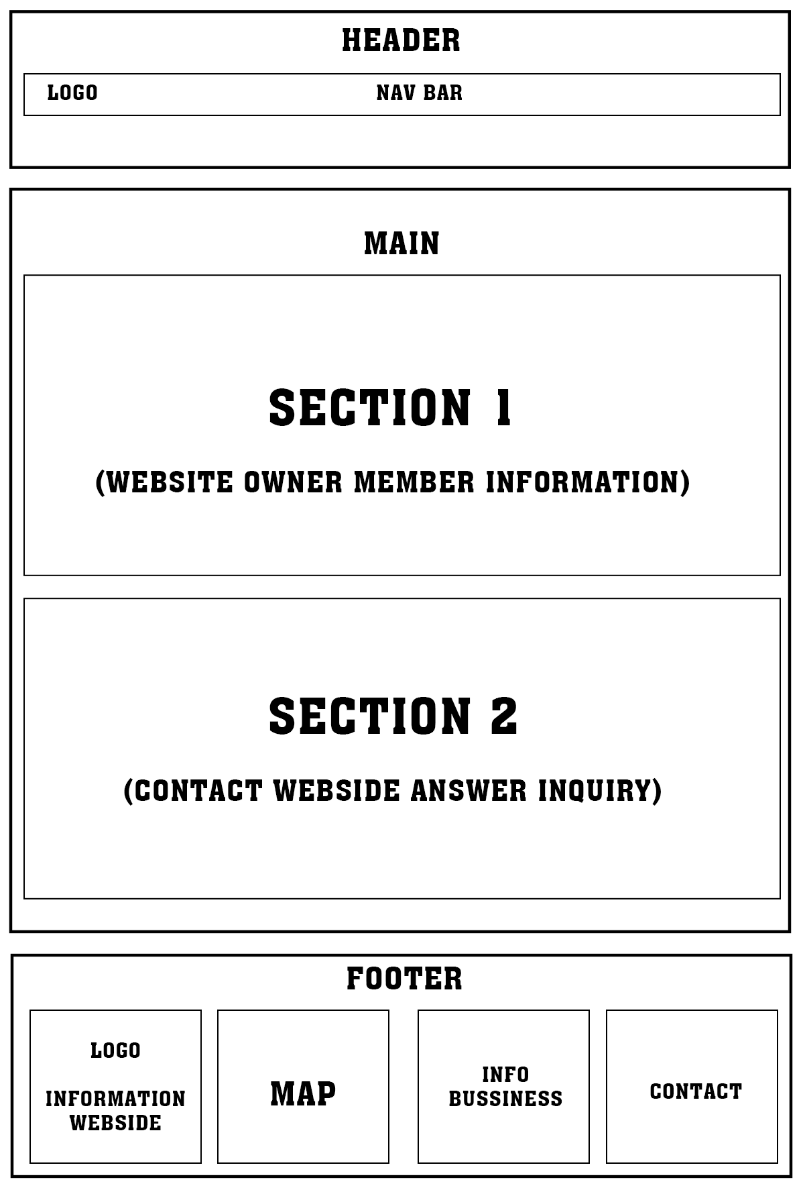

1. **Sign in -Sign out**

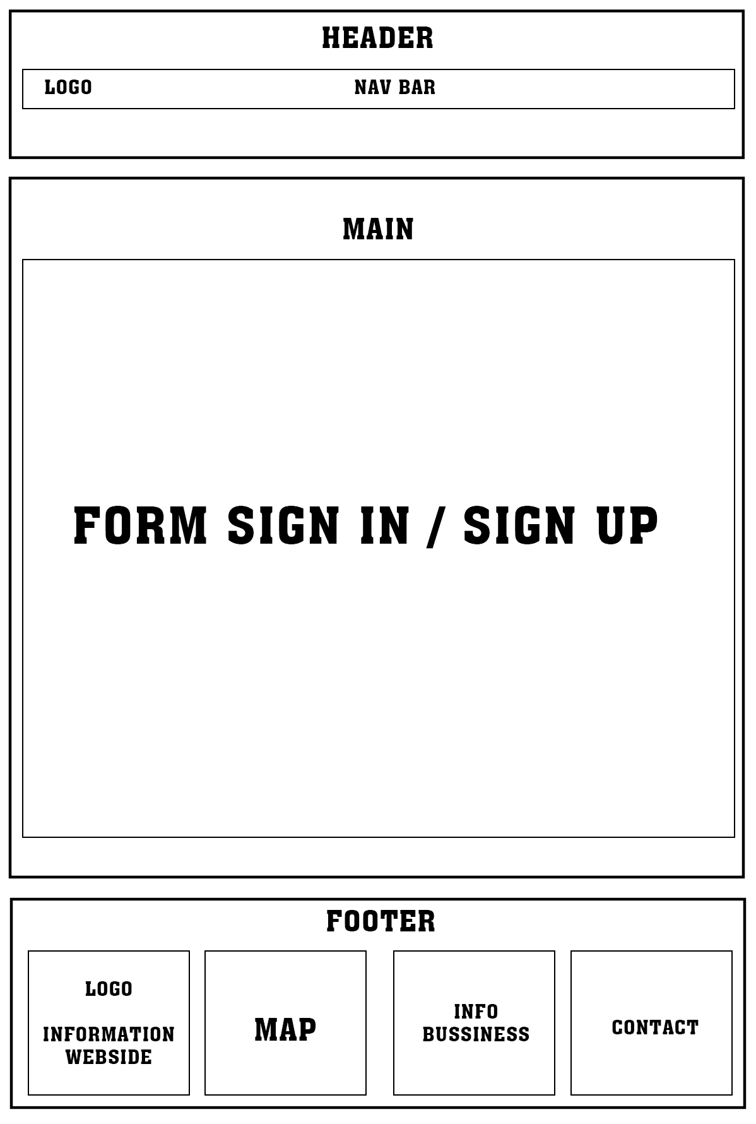

1. **Logo.**





# TASK SHEET REVIEW 2

|  |  |  |  |  |  |  |  |
| --- | --- | --- | --- | --- | --- | --- | --- |
| **Project Ref. No.:**  **e-P/Advertisement**  **Portal Management System/01** | | **Project Title:** | **Activity Plan Prepared By:** | **Date of Preparation of Activity Plan:** | | | |
| **Sr.**  **No.** | **Task** | **Actual Start Date** | **Actual Days** | **Team Mate Names** | **Status** |
| 1 | Site map | Astronomy Space-K | Viet  Huy  Thinh | 27th-May-2023 | 2 | Nguyen The Huy | Completed |
| 2 | Mock of the website | 27th-May-2023 | 2 | Tran Quoc Viet | Completed |
| 3 | Task sheet | 27th-May-2023 | 2 | Luong Minh Thinh | Completed |

|  |  |
| --- | --- |
| **Date: 30th May 2023** | |
| Signature of Instructor:  **Ms. Le Mong Thuy** | Signature of Team Leader:  **Tran Quoc Viet** |

# WEBSITE DESCRIPTION

1. **Home page.**
2. Description: Home page displays following information.
   * + Introduction.
     + Highlighted information.
3. Screenshot.

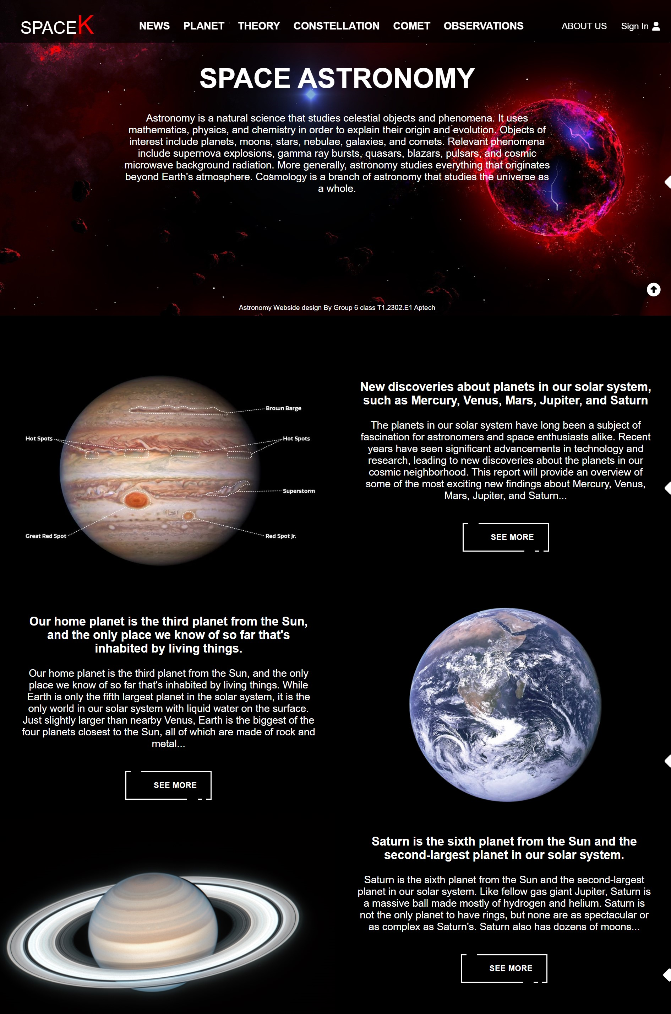

1. **News.**
   1. *List of News.*
2. Description: List of news display following information.
   * + There is a search bar for users to find information.
     + Show all news.
   1. Screenshot:

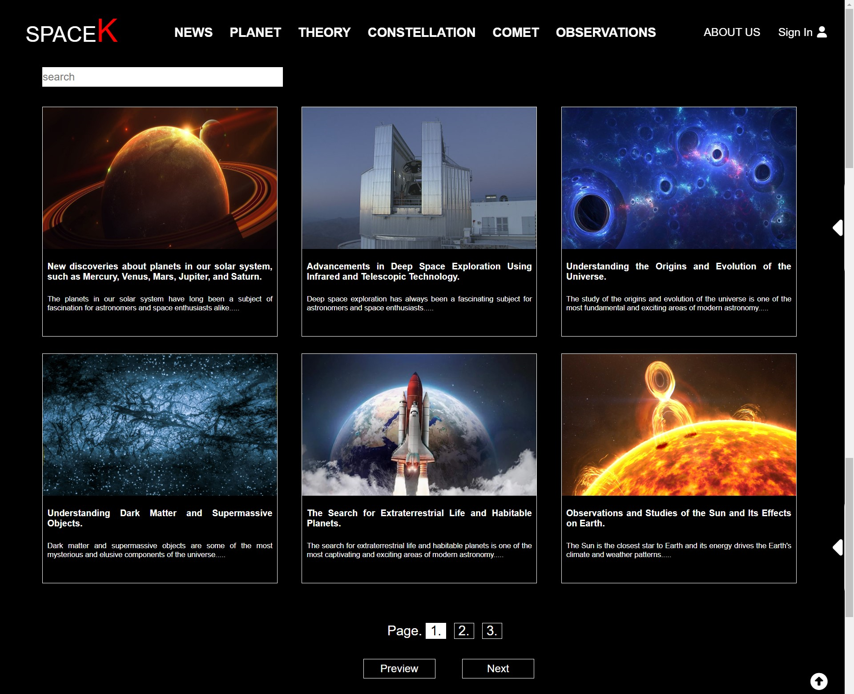

* 1. *Detailed information.*

1. Description.

- Show the article.

- There is a comment section for registered and successfully logged-in users.

- There is a section of suggested articles for users.

1. Screenshot.

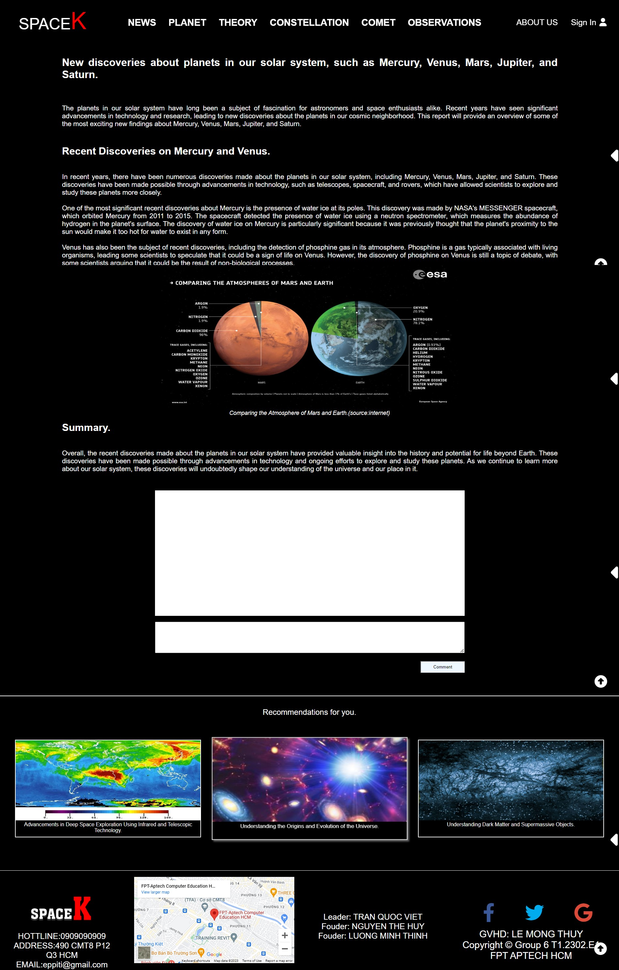

1. **Planet.**
   1. *List of Planet.*
2. Description.

-Display a map of the solar system.

1. Screenshot.

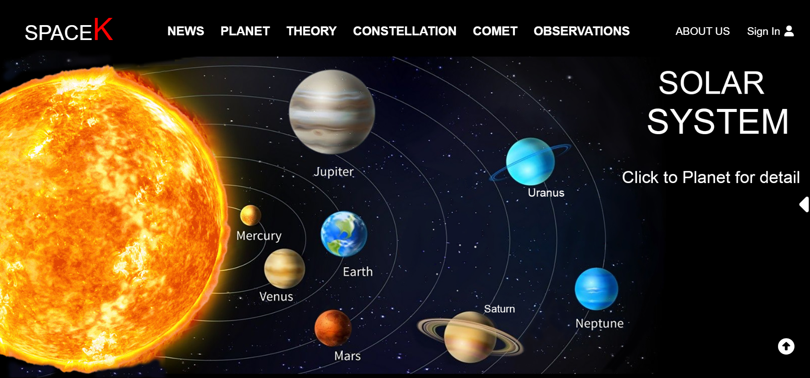

* 1. *Detailed information**.*

1. Description.

- Show the article.

- There is a comment section for registered and successfully logged-in users.

- There is a section of suggested articles for users.

1. Screenshot.

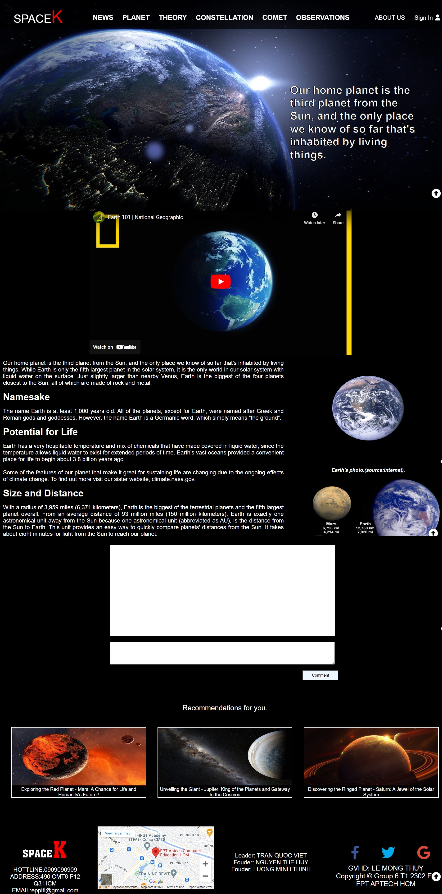

1. **Theory.**
   1. *List of Theory.*
2. Description.
   * + The Big Bang Theory.
     + The Evolution of Earth.
3. Screenshot.

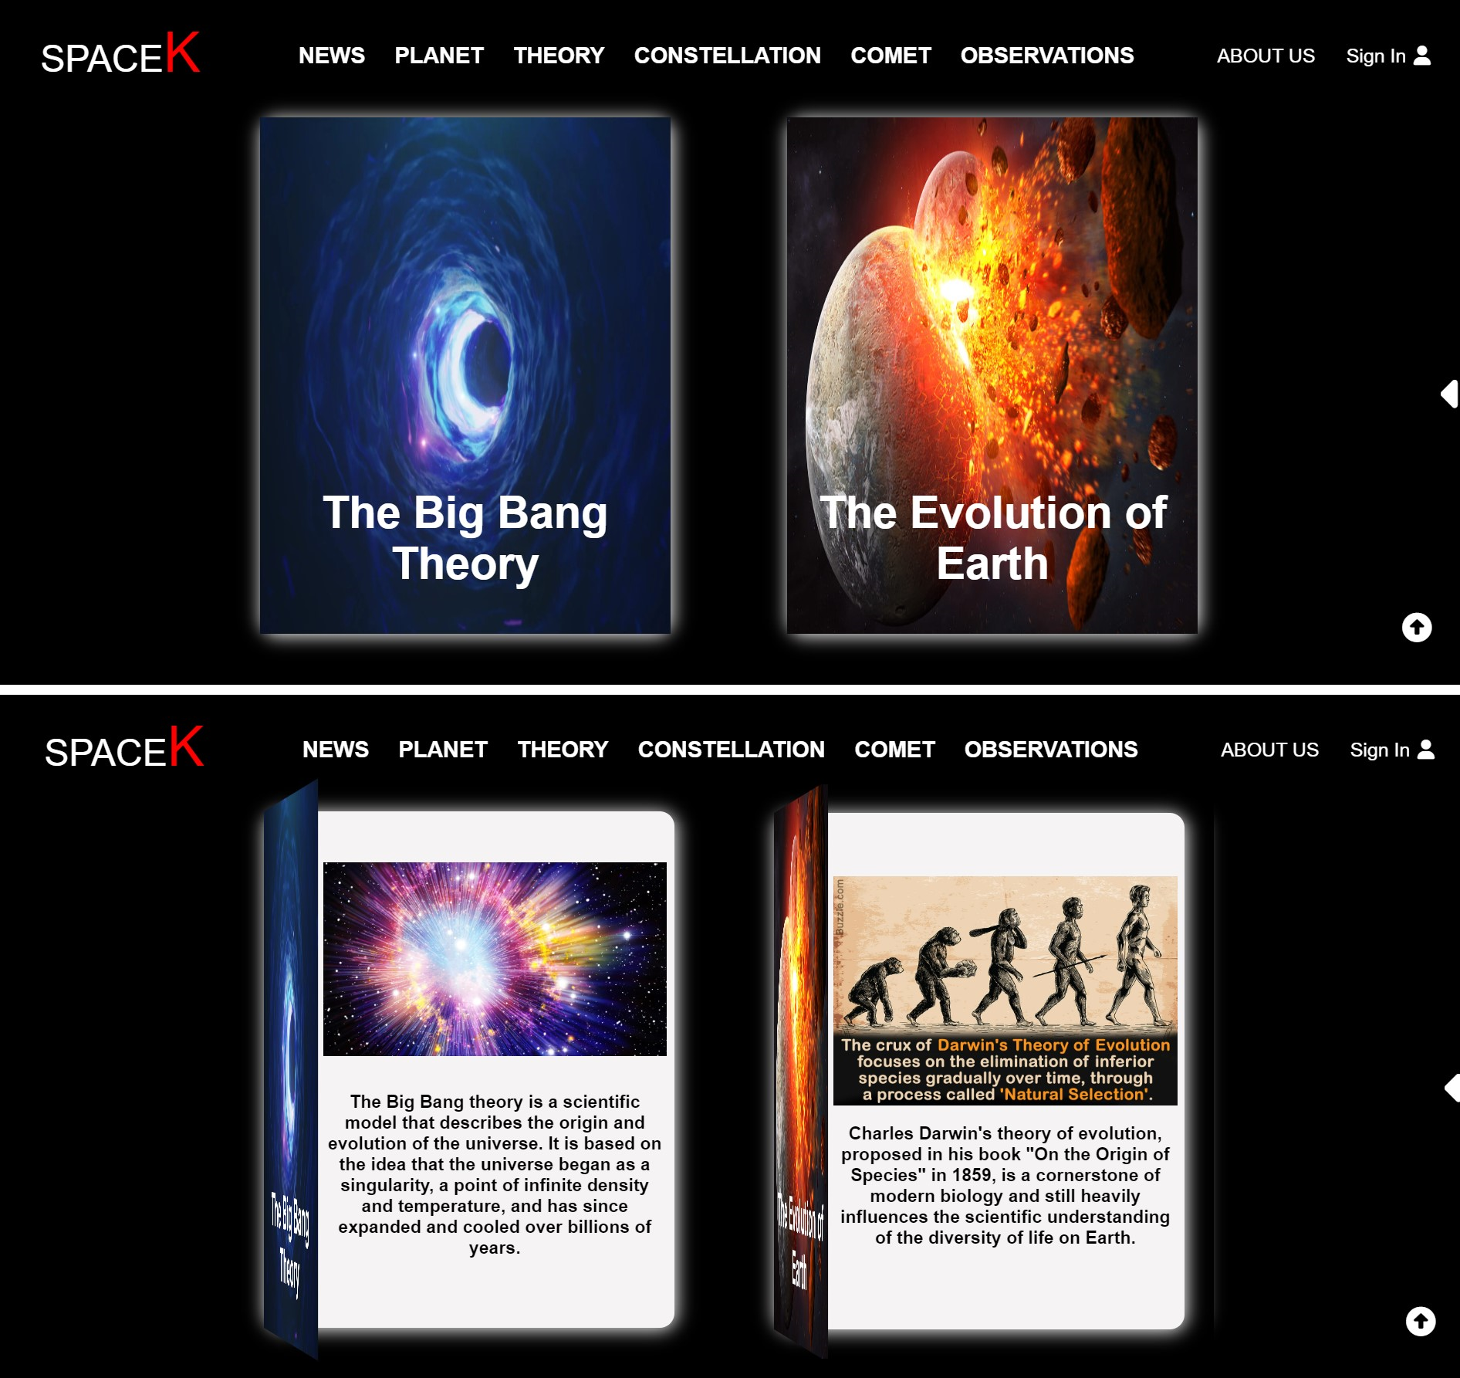

* 1. *Detailed information.*

1. Description.
   * + Show the article.
     + There is a comment section for registered and successfully logged-in users.
2. Screenshot.

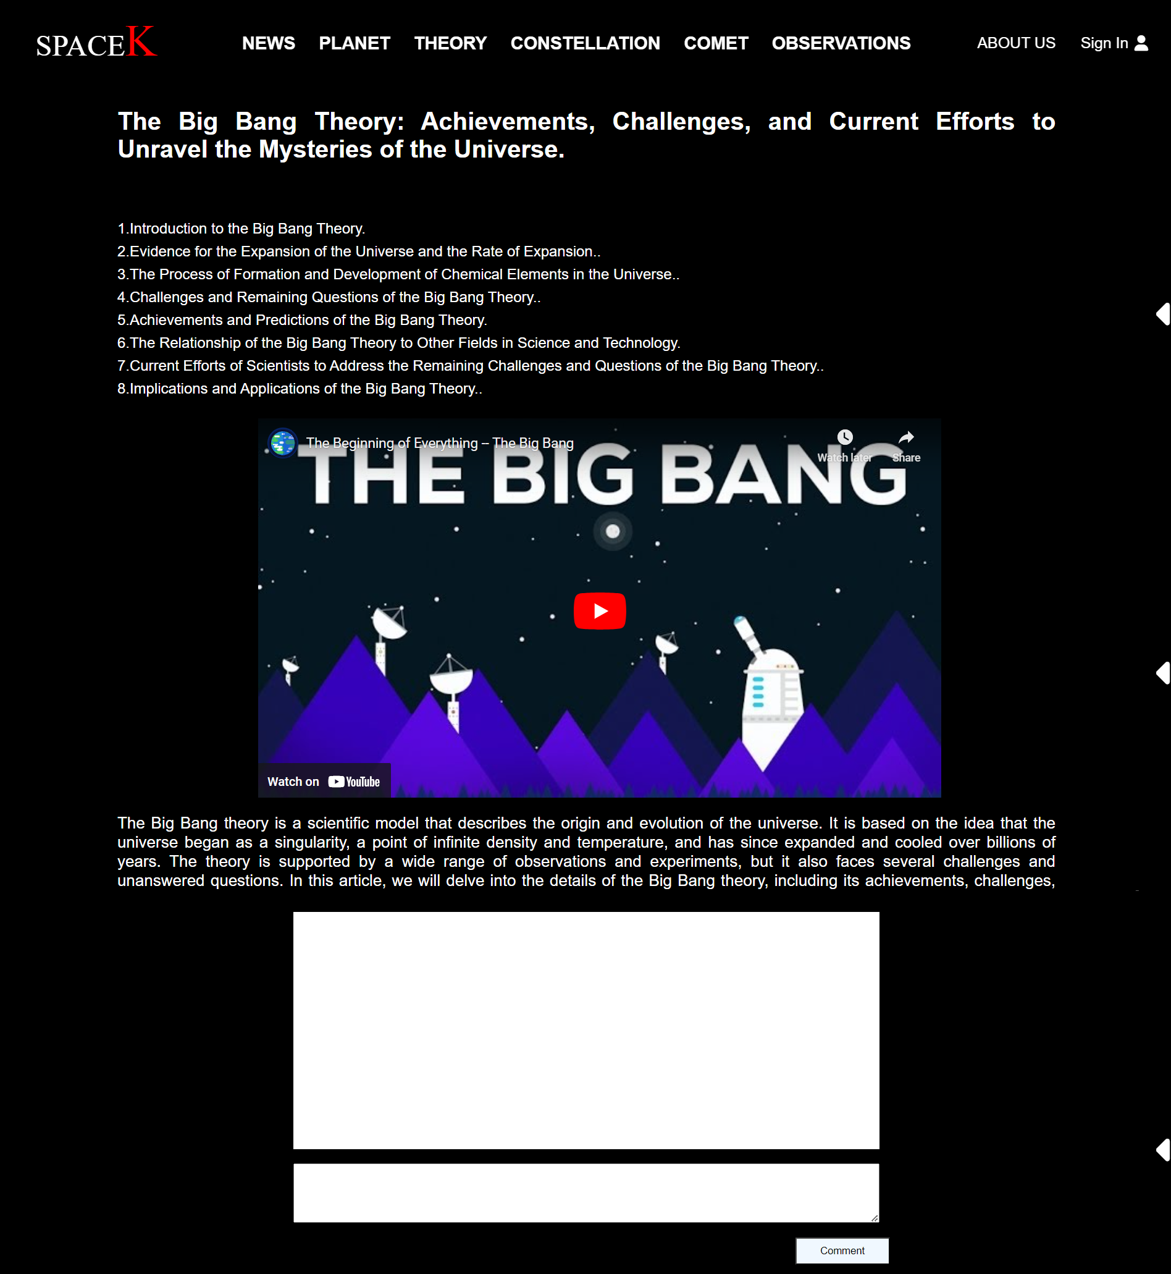

1. **Constellation.**
   1. *List of Constellation.*
2. Description.
   * + There is a search bar for users to find information.
     + Show all Constellation.
     + Explore the personalities of the zodiac signs.
3. 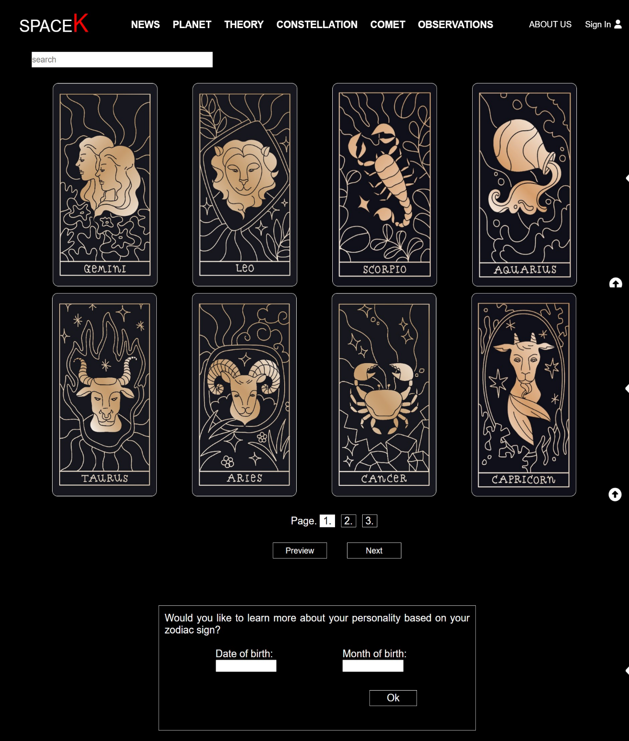Screenshot.
   1. *Detailed information.*
4. Description.
   * + Show the article.
     + There is a comment section for registered and successfully logged-in users.
     + There is a section of suggested articles for users.
5. Screenshot.

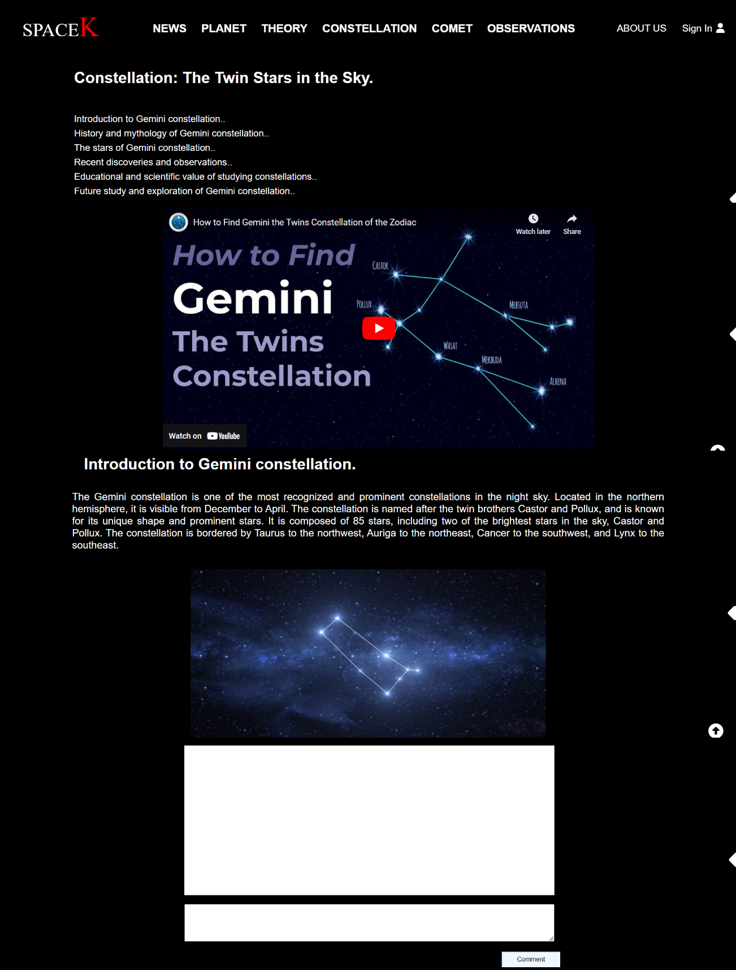

* 1. *Explore the personalities of the zodiac signs.*

1. Description.
   * + Enter your date and month of birth into the input field, press OK, and wait for the result to be returned.
     + Click on the displayed card to get information.
2. Screenshot.

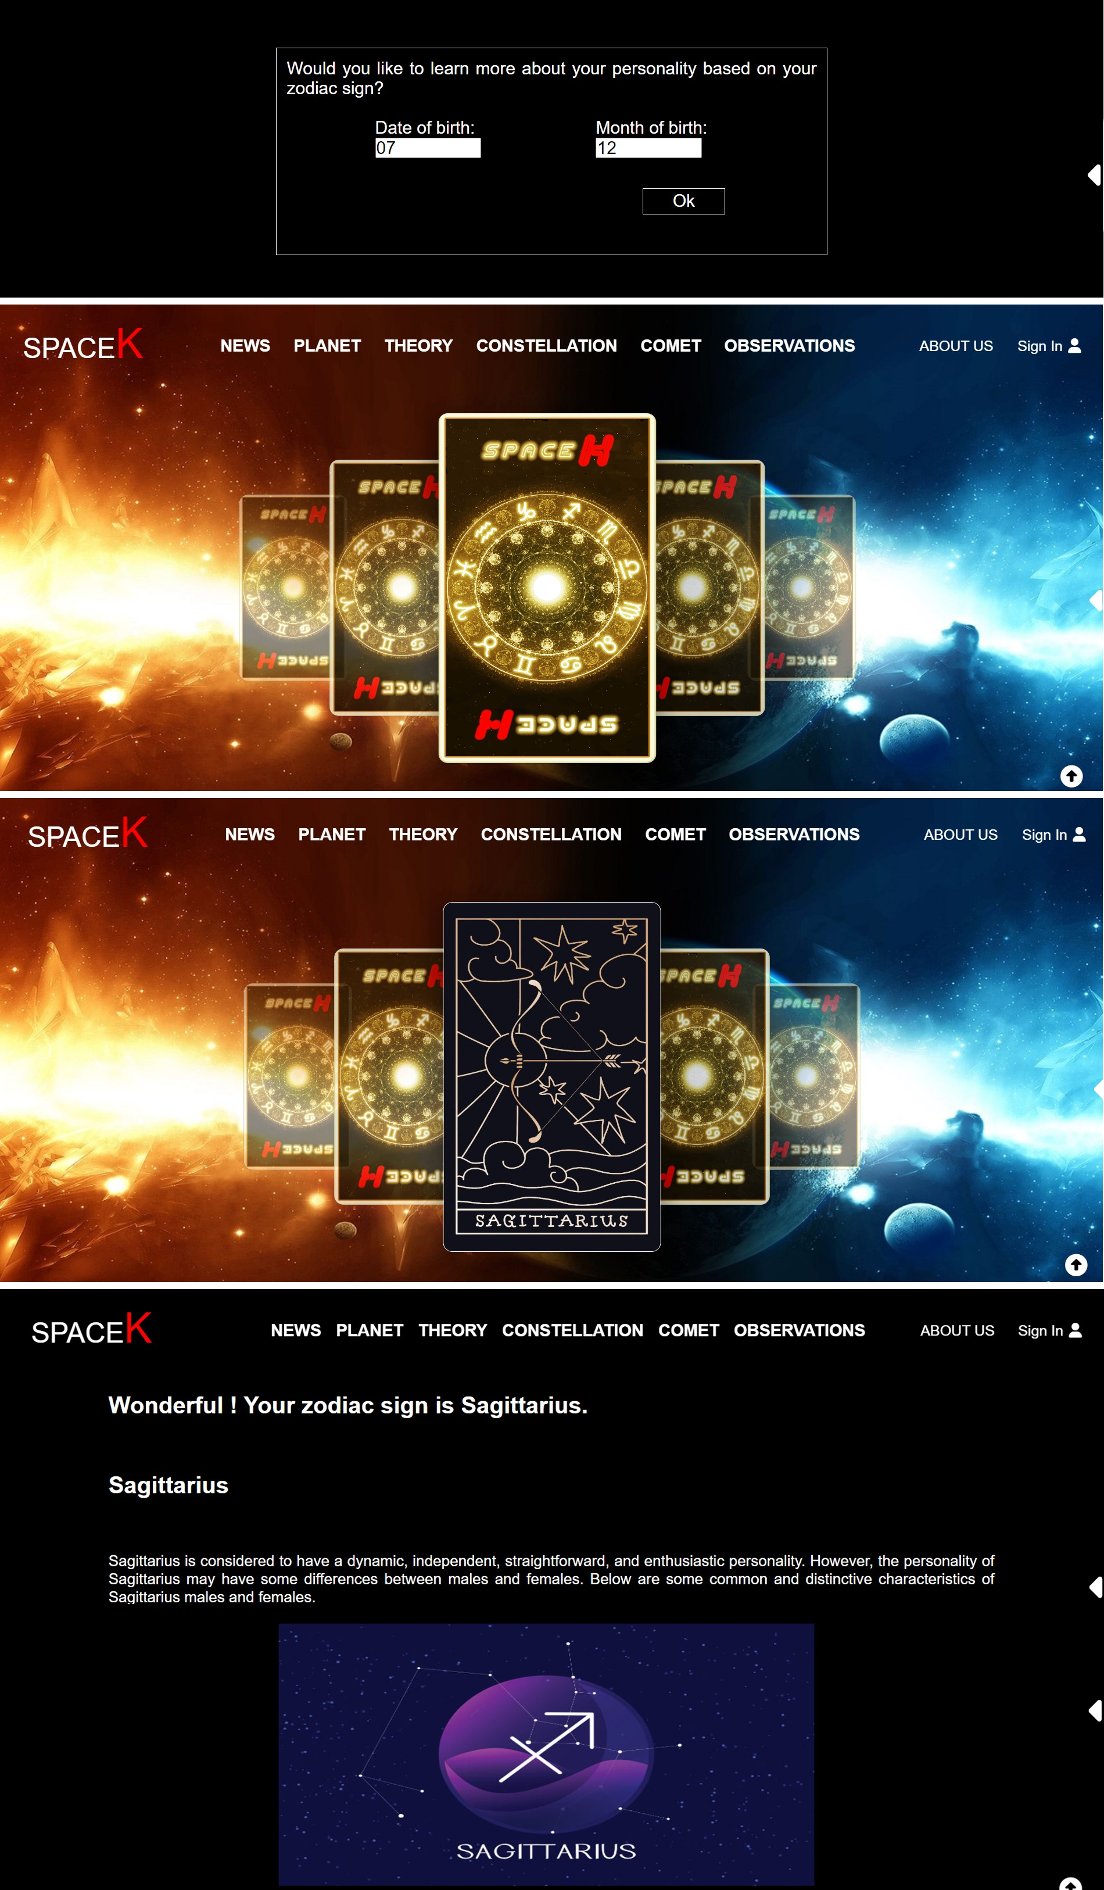

1. **Comet.**
   1. *List of Comet.*
2. Description.
   * + Halley’s Comet.
     + Hale-Bopp Comet.
     + Hyakutake Comet.
3. Screenshot.

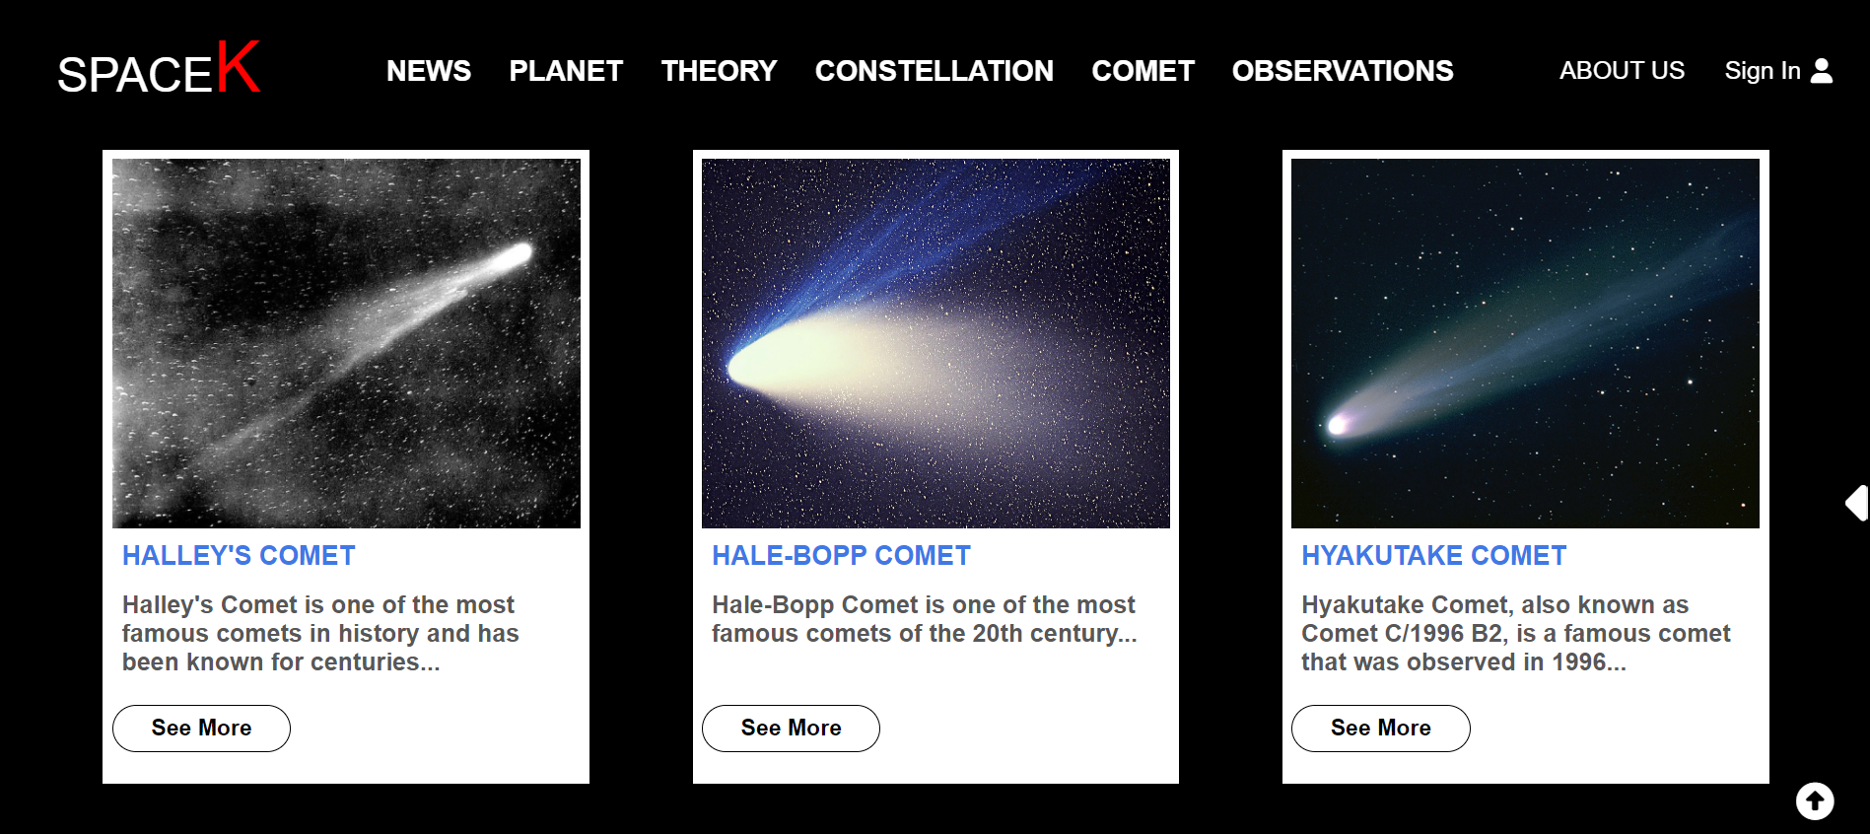

### *6.2 Detailed information.*

1. Description
   * + Show the article.
     + There is a comment section for registered and successfully logged-in users.
2. 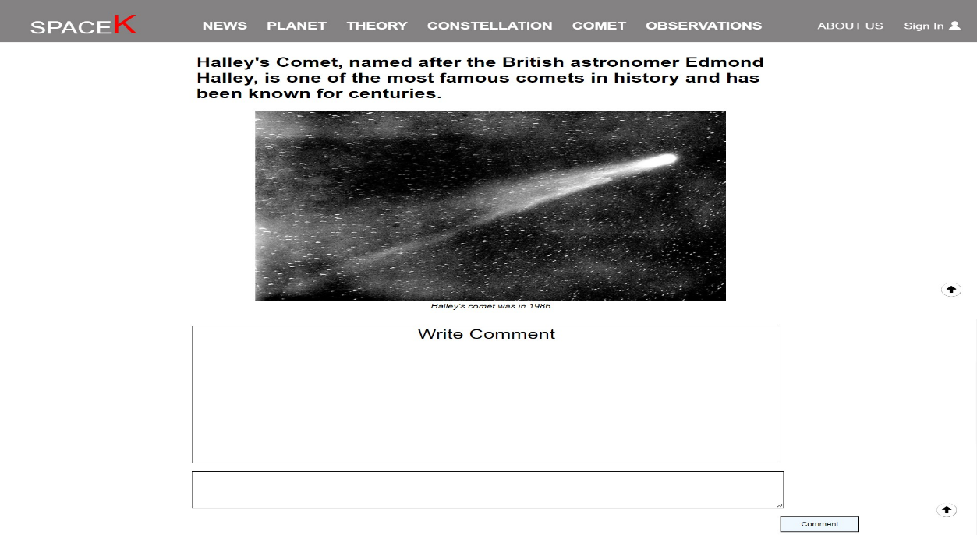Screenshot
3. **Observations.**
   1. *List of Observations.*
4. Description.
   * + FAST Observatory – China.
     + The Very Large Telescope (VLT) – Chile.
     + Keck Observatory – Hawaii, USA.
5. Screenshot.

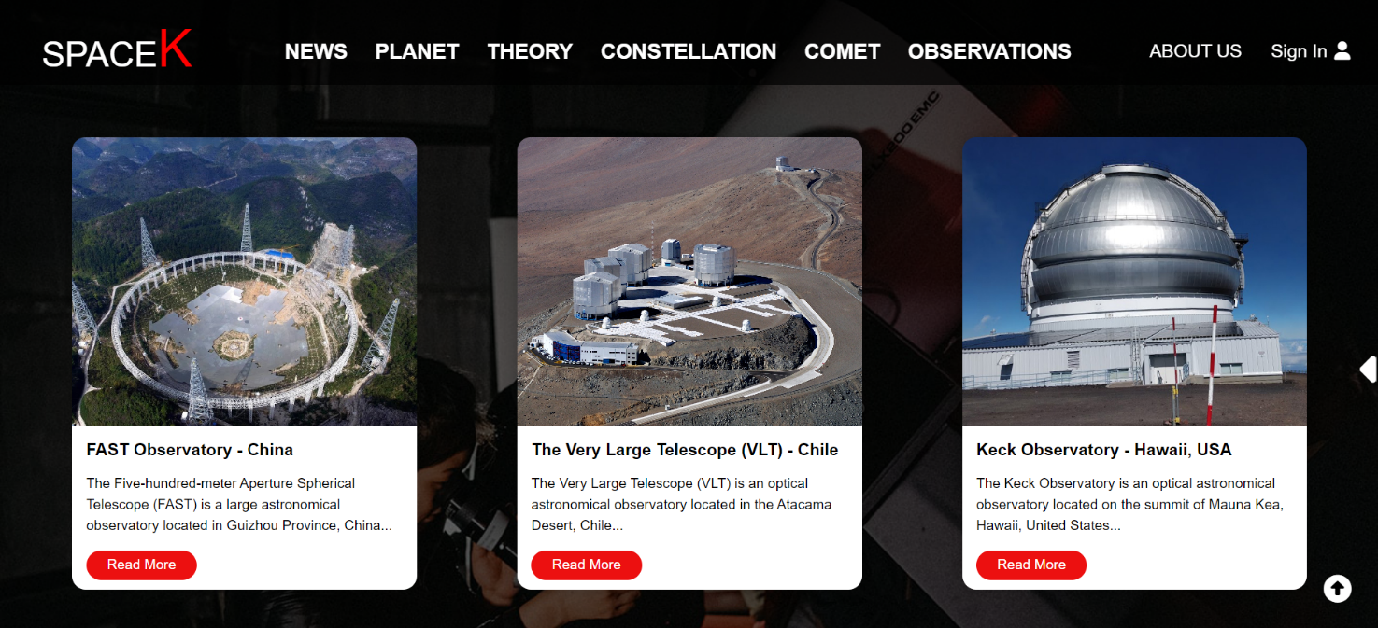

* 1. *Detailed information.*

1. Description.
   * + Show the article.
     + There is a comment section for registered and successfully logged-in users.
2. 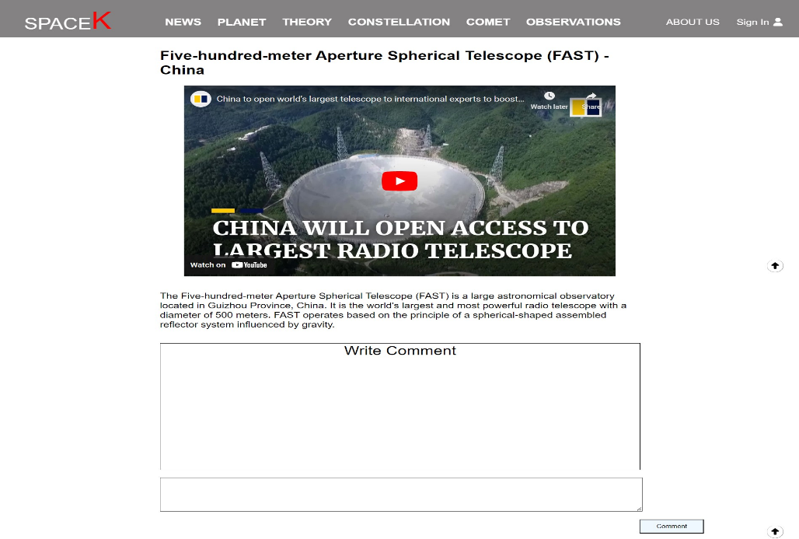Screenshot.
3. **About us.**
4. Description.

Contact and Team Member.

1. Screenshot.

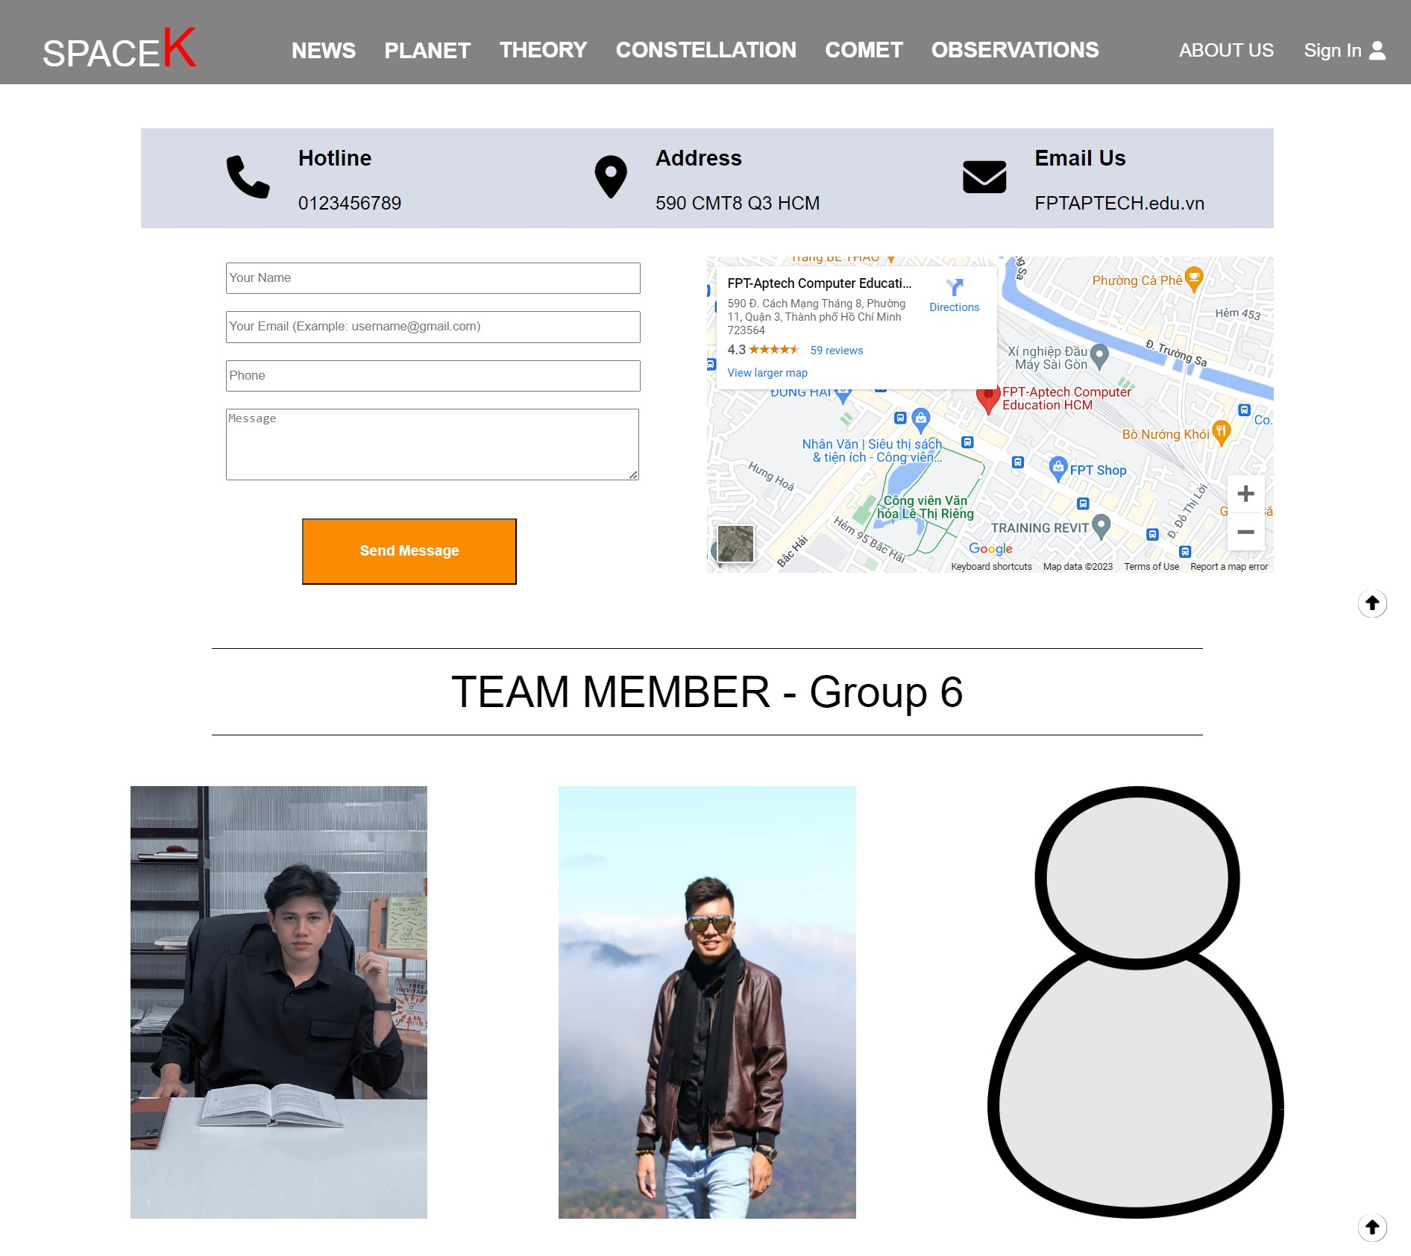

1. **Sign in/Sign up.**
2. Description.

Display the login field, and if the user does not have an account, they can register for one.

1. Screenshot.

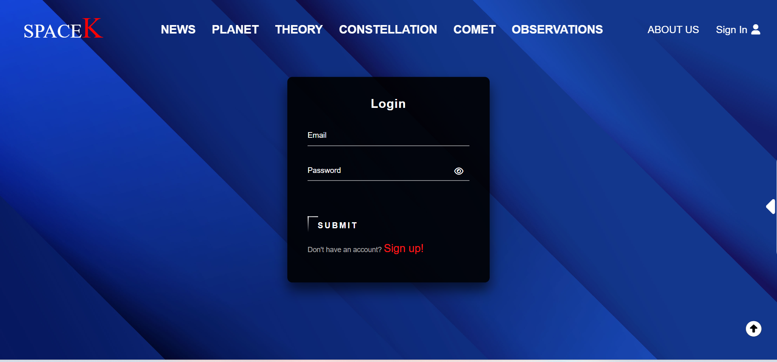

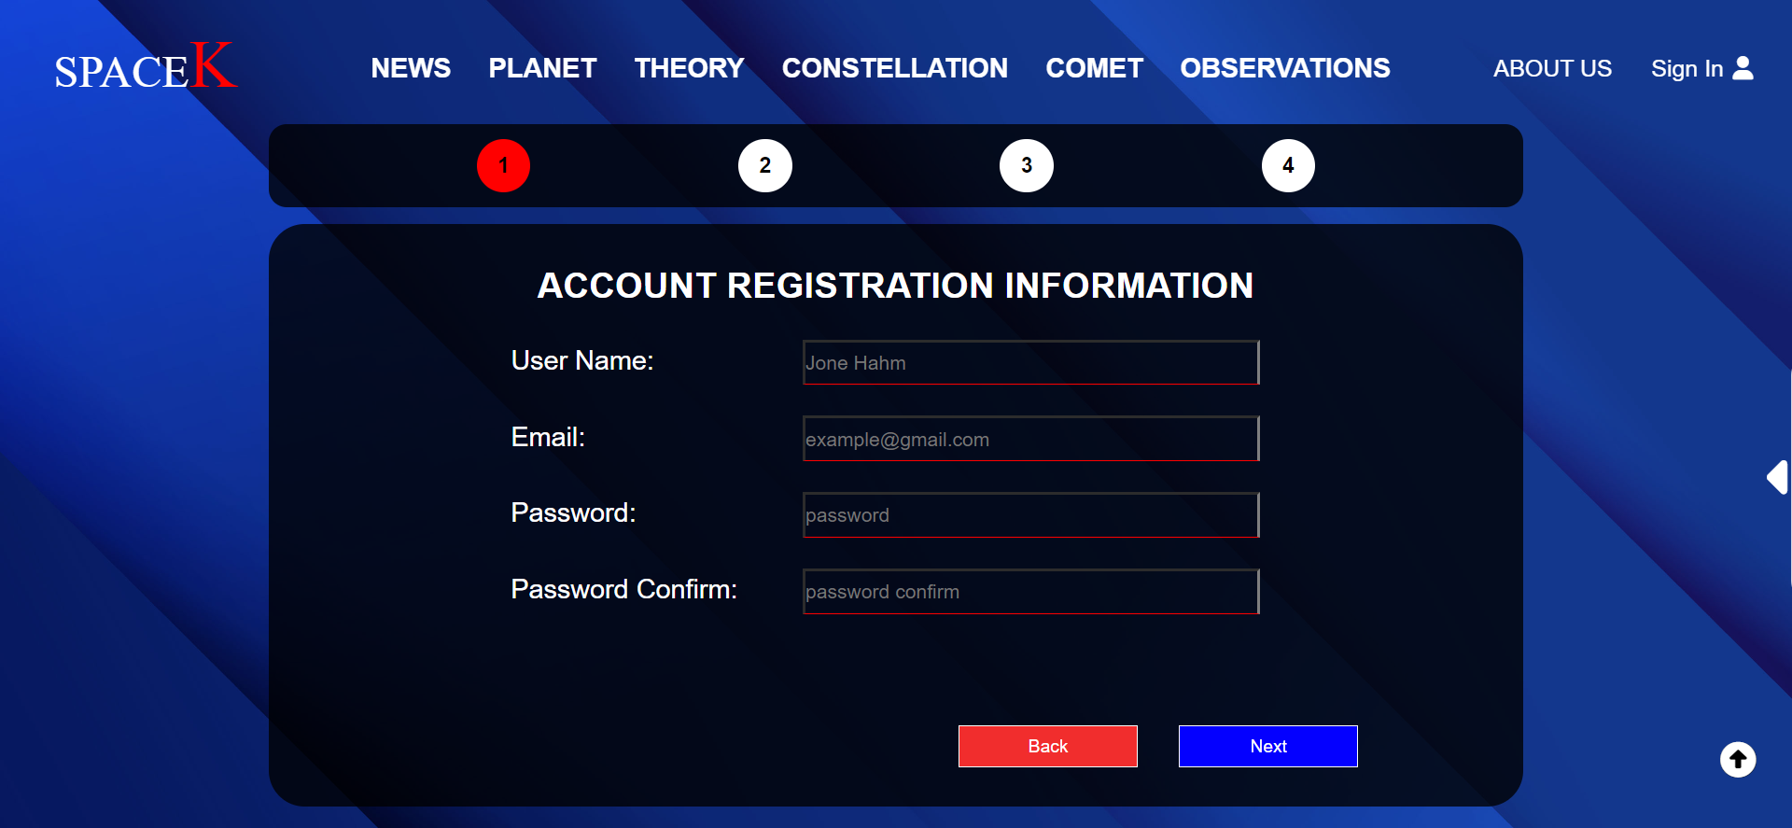

**JAVASCRIPT DESCRIPTION**

## Catch-all event.

* 1. Description.

-Scroll event, when scrolling down, the menu bar will be hidden. When scrolling up, the menu bar will reappear.

-Display the login username on the menu bar, check if the user is logged in, and if so, allow them to comment on posts.

-Display user comments on posts.

* 1. Screenshot.

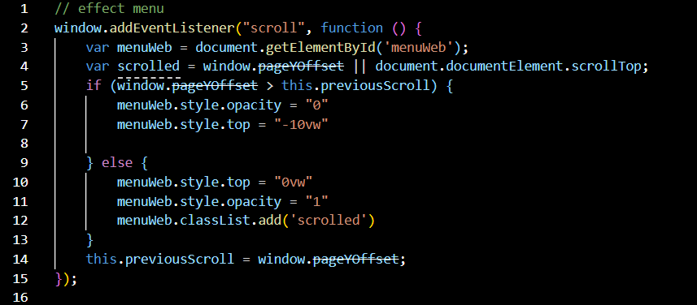

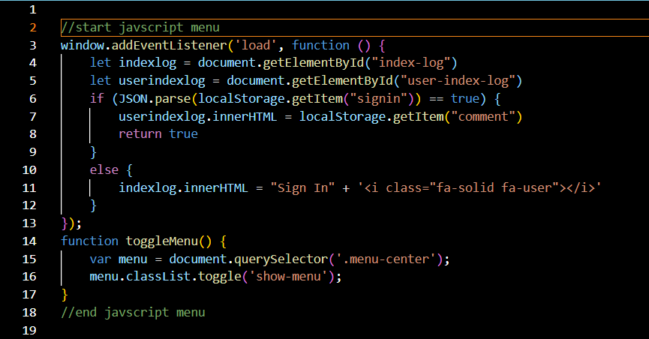

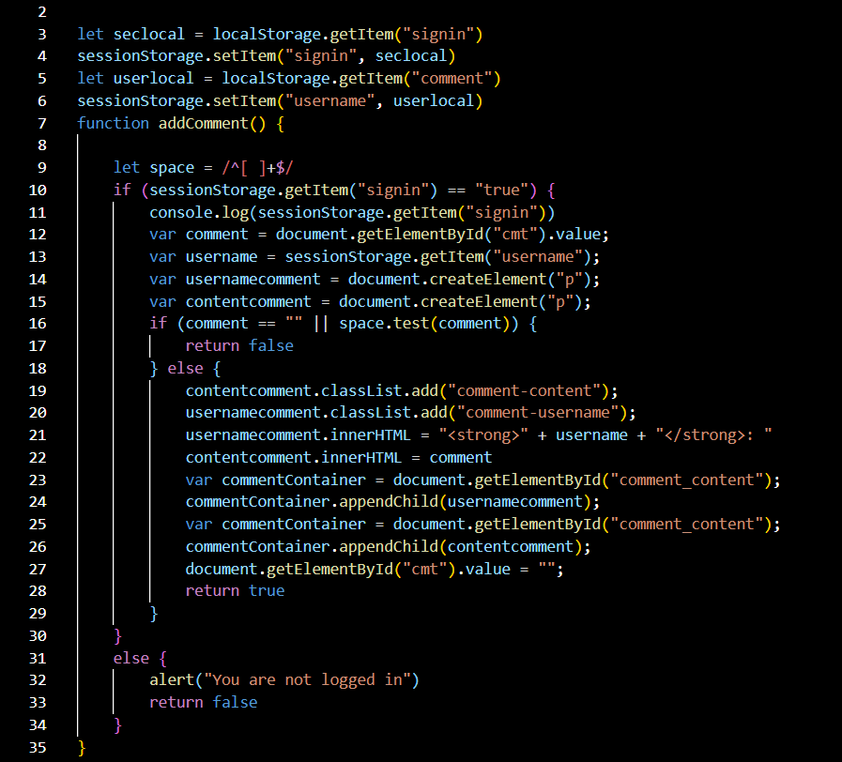

## Product data Json and JavaScript.

* 1. Description.

- Retrieve data from a JSON file to display on a website.

* 1. Screenshot.

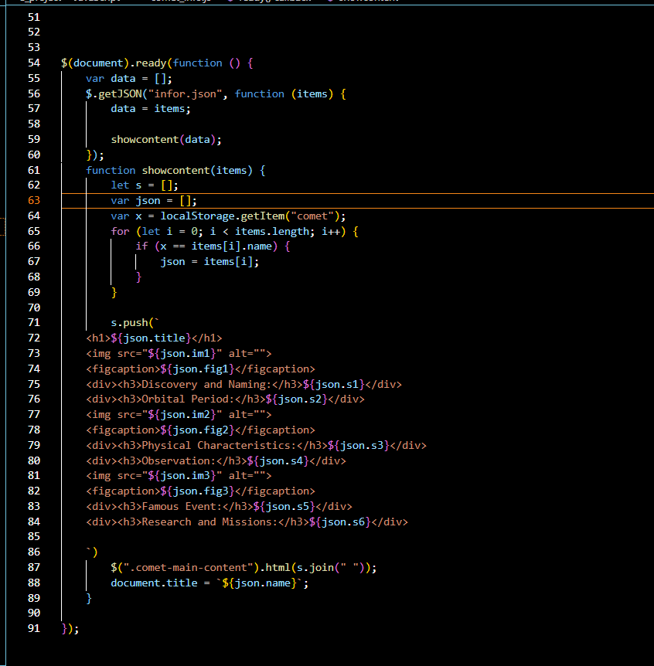

1. **Sign in**
   1. Description.

- Check if the account exists, and save the logged-in account information to local storage.

- On the menu bar, you can log out if you want.

* 1. Screenshot.

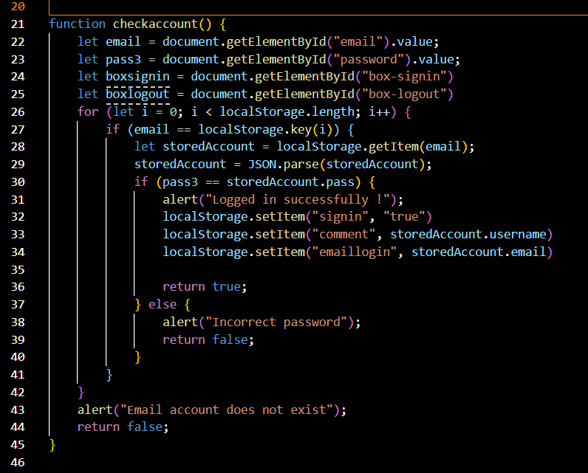

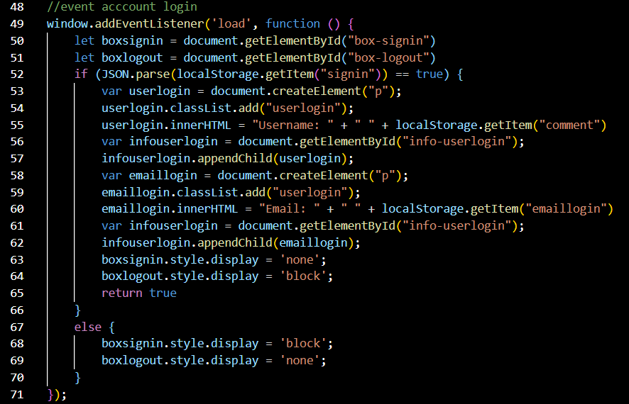

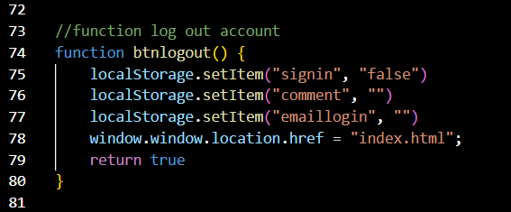

1. **Sign up.**
   1. Description.
      * Check whether the user's registration data meets the requirements.
      * Display registered information.
   2. Screenshot.

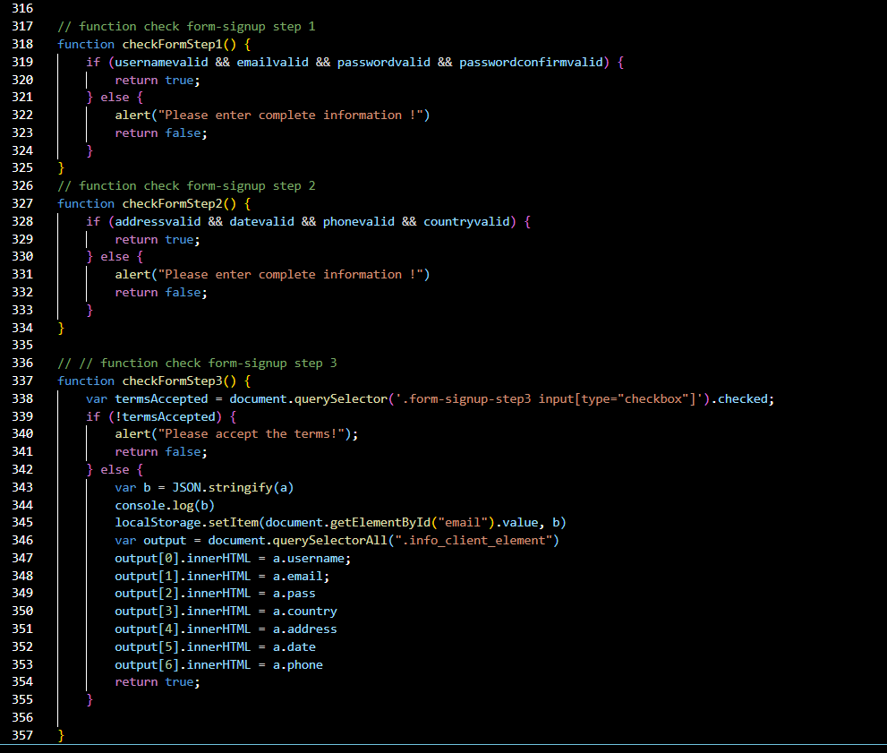

1. **Index.**
2. Description.

Display content.

1. Screenshot.

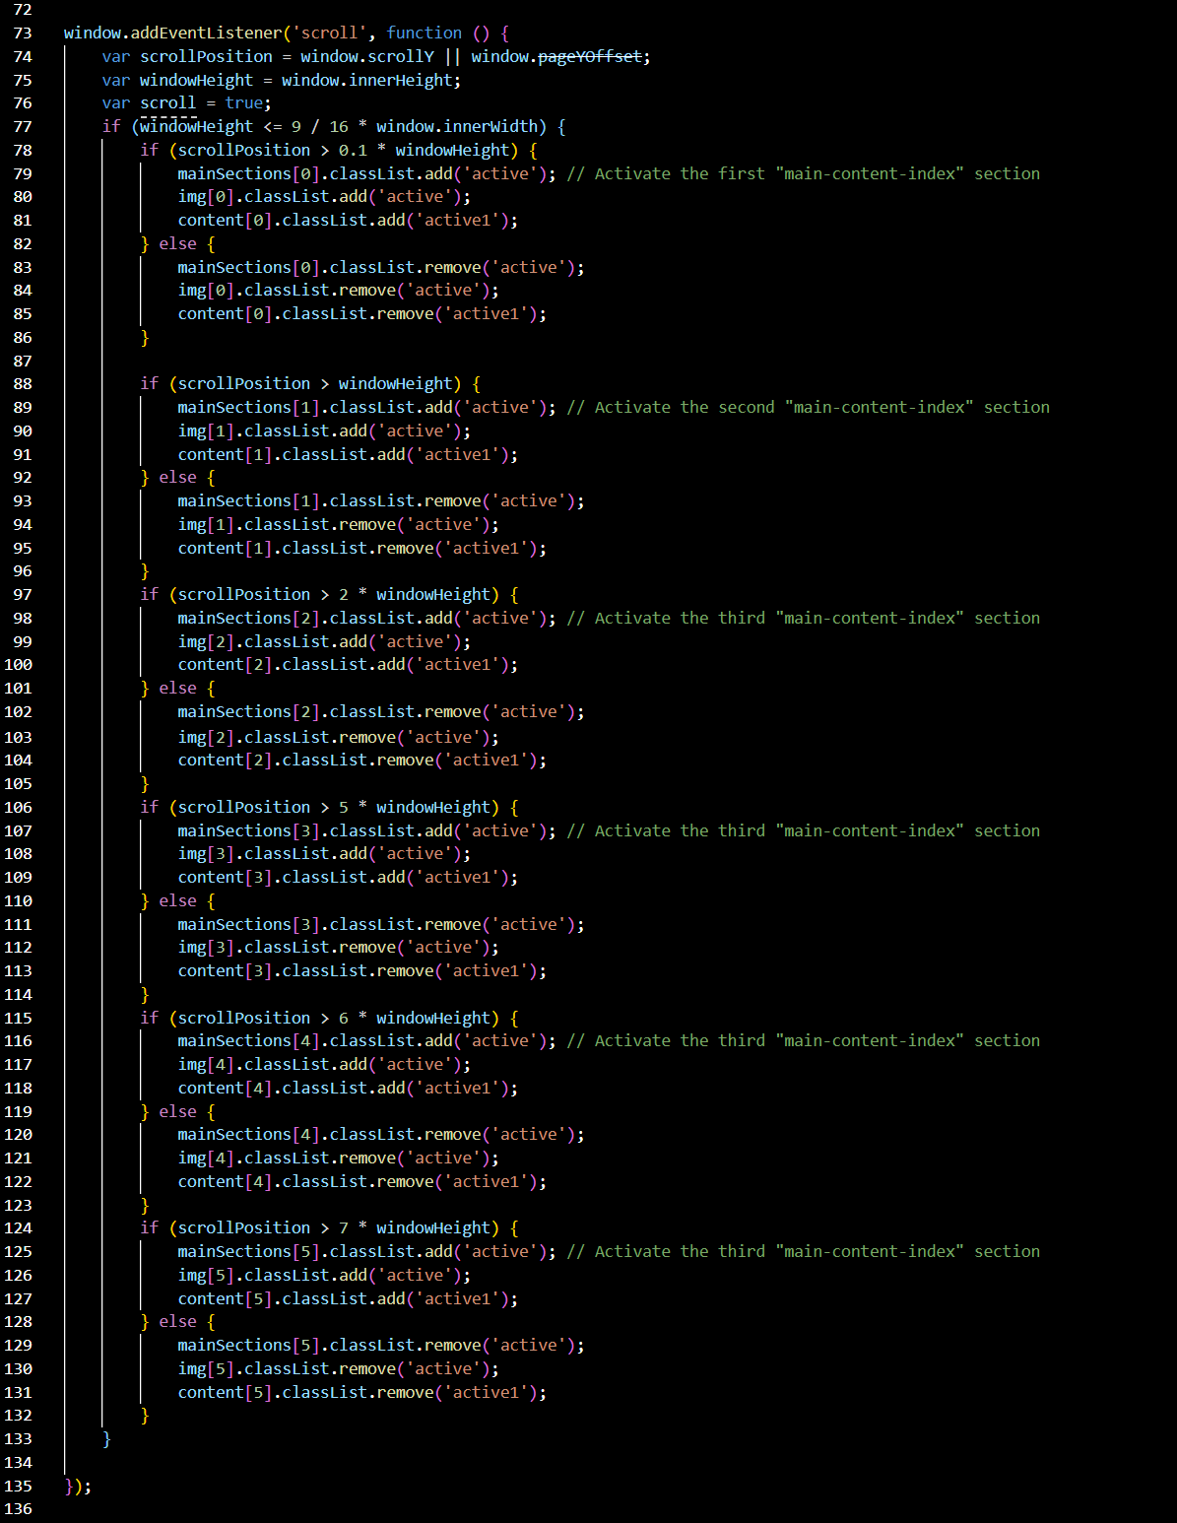

1. **Page list.**
   1. Description.

* Set values for titles to link to detailed information pages.
* Use AngularJS to implement searching for posts. Divide a list of titles into small pages for display.
  1. Screenshot.

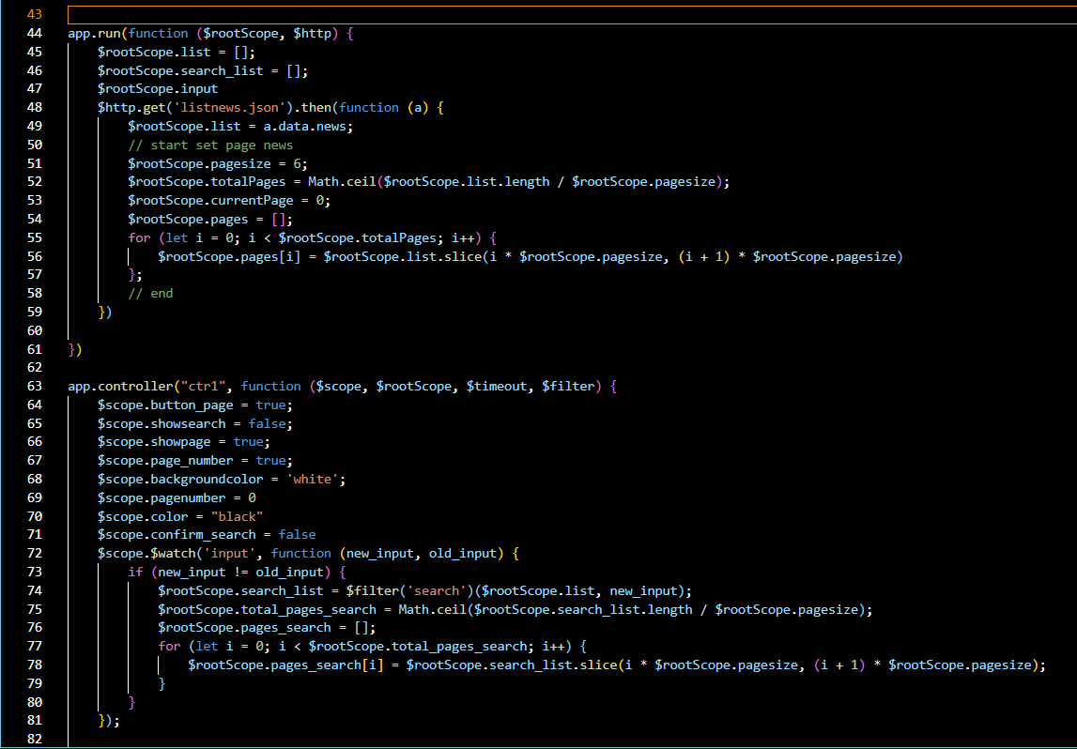

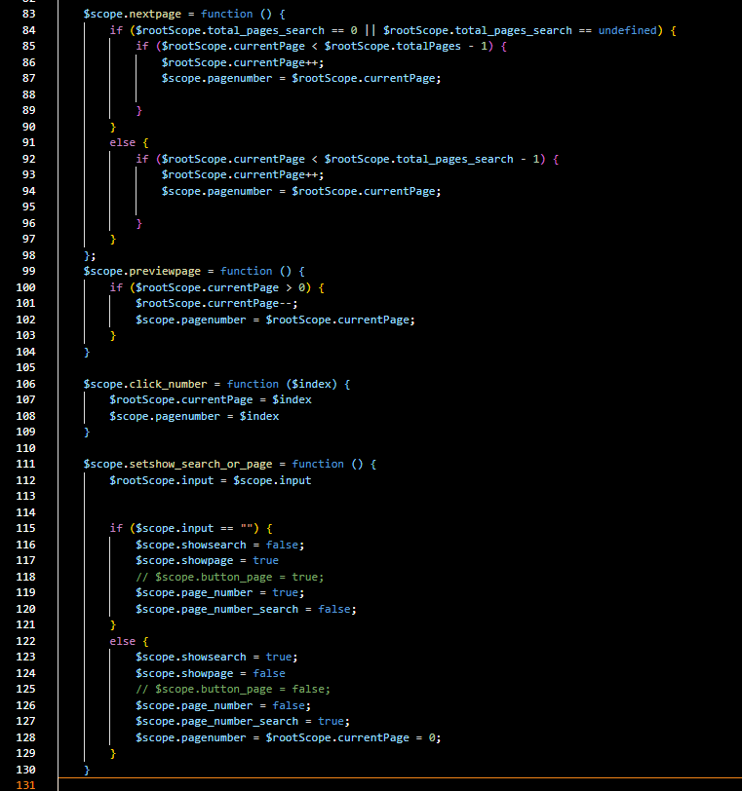

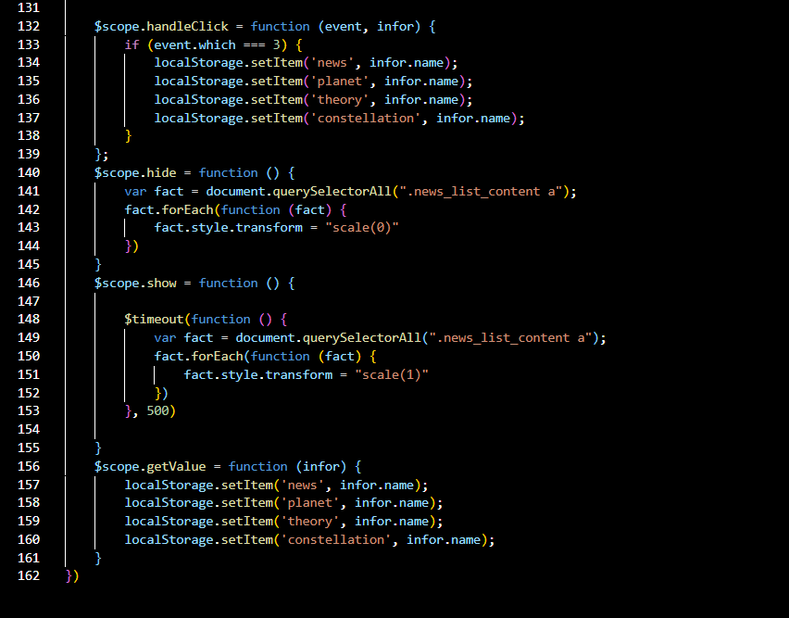

1. **Lucky Spin.**
   1. Description.

* Retrieve the user's date of birth data to perform a game.
* Retrieve user data when they spin a wheel.
  1. Screenshot.

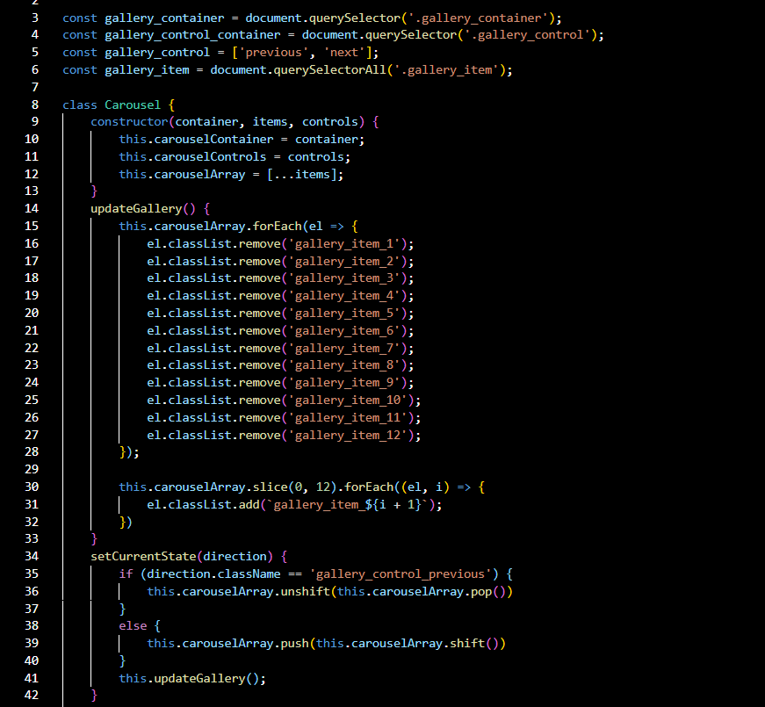

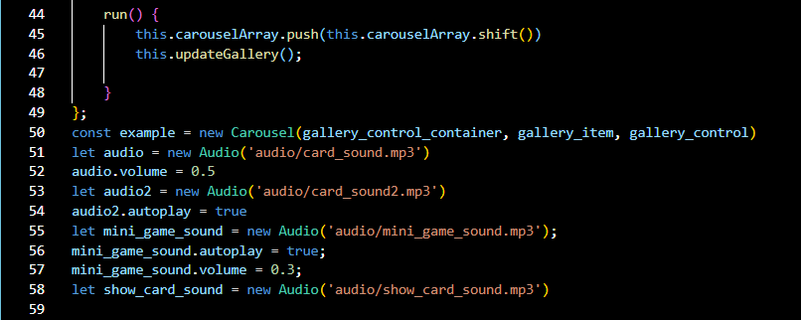

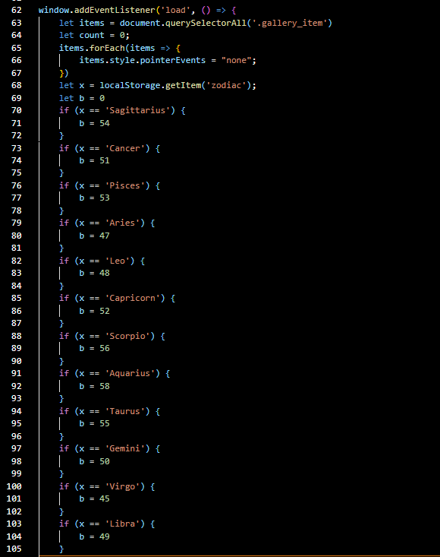

# TASK SHEET REVIEW 3

|  |  |  |  |  |  |  |  |  |
| --- | --- | --- | --- | --- | --- | --- | --- | --- |
| **Project Ref. No.:**  **e-P/Advertisement**  **Portal Management System/01** | | **Project Title:** | **Activity Plan Prepared By:** | **Date of Preparation of Activity Plan:** | | | | |
| **Sr.**  **No.** | **Task** | **Actual Start Date** | **Actual Days** | **Team Mate Names** | **Status** |
| 1 | Website layout | Astronomy Space-K | Viet  Huy | 28th-May-2023 | 2 | Nguyen The Huy | Completed |
| 2 | Edit CSS | 30th-May-2023 | 10 | Nguyen The Huy | Completed |
| 3 | Modal JavaScript | 30th-May-2023 | 10 | Tran Quoc Viet | Completed |
| 4 | Filter & comparison javascript | 9th-June-2023 | 5 | Nguyen The Huy | Completed |
| 5 | Product detail and data json | 9th-June-2023 | 5 | Tran Quoc Viet | Completed |
| 6 | Task sheet review | 14th-June-2023 | 1 | Tran Quoc Viet | Completed |

|  |  |
| --- | --- |
| **Date: 20th June 2023** | |
| Signature of Instructor:  **Ms. Le Mong Thuy** | Signature of Team Leader:  **Tran Quoc Viet** |